

2022 summer project

Evolutionary algorithms

Student name: Mei Jiaojiao

Neptun code: V6fisc

Mentor: Prof. Gulyás László  
Email: [v6fisc@inf.elte.hu](mailto:v6fisc@inf.elte.hu)

College name: Eötvös Loránd University

Table of Contents

1 Introduction 3

1.1 CEC-BC- 2017 3

1.2 Genetic algorithms 4

1.3 Steady-state Genetic Algorithms 5

1.4 Crossover 6

1.4.1 singe-point-crossover 6

1.4.2 Probabilistic crossover 7

1.4.3 Linear combination crossover 7

1.5 Mutation 8

1.5.1 uniform mutation 8

1.5.2 normal mutation 8

1.6 Baldwin effect and Lamarckian evolution 9

1.6.1 Genotype and Phenotype 9

1.6.2 Local Search Procedures 9

1.6.2.1 Baldwin effect 9

1.6.2.2 Lamarckian evolution 10

1.7 Evolutionary Algorithms 10

1.7.1 SSGA 10

1.7.2 Baldwin algorithm vs Lamarck algorithm 11

2 Exploration on parameters 12

2.1 Experiment1 13

2.1.1 Data visualization 13

2.1.1.1 Fitness plot for Experiment1 13

2.1.1.2 Percentage plot for Experiment1 16

2.1.1.3 Violin plot for parameter exploration 18

2.1.2 Conclusion of Experiment 1 22

2.2 Experiment2 24

2.2.1 Conclusion of Experiment 2 25

2.3 Experiment3 25

2.3.1 Conclusion of Experiment 3 28

2.4 Experiment4: SSGA in 10 dimensions 28

2.4.1 Scatter plots 29

2.4.2 Best 20 parameter combination 31

2.5 Experiment5: SSGA in 50 dimensions 32

2.5.1 Percentage Table 32

2.5.2 Conclusion of Experiment5 38

2.5.3 Issues with Experiment5 38

2.5.3.1 F19 38

2.5.3.2 Bad performance on power computation 38

2.6 Experiment6: Baldwin and Lamarck on best 20 38

2.6.1 Percentage tables 39

2.6.2 Evaluation of local search procedures 44

2.6.2.1 Comparison between SSGA and Lamarck 45

2.6.2.2 Comparison between SSGA and Baldwin 46

2.6.3 Conclusion of Experiment6 47

3 Conclusion and Further Work 48

4 References 48

Steady-state Genetic Algorithms and Extensions of Baldwin effect and Lamarckian evolution

**Abstract**

The summer project is concerned with the steady-state genetic algorithm (SSGA) for finding the global minimums of the test function group CEC-BC- 2017 [1]. Each test function has different number of dimensions, domain, and global minimum. All the test functions used in this summer project are presented in Table 1. The main goal is to examine the importance of the proposed local search procedures of Baldwin effect and Lamarckian evolution based on SSGA in finding global minimums to CEC-BC- 2017.

**Keywords**: Baldwin effect, Evolutionary algorithm, Genetic algorithm, Lamarckian evolution, Steady state, CEC-BC- 2017

# Introduction

## CEC-BC- 2017

Table 1-1 shows all the test functions used in this study. Dim means dimensions of each test function, Optimal means the global minima in this domain.

Table 1‑1

|  |  |  |  |
| --- | --- | --- | --- |
| Function | Domain | Dim | Optimal |
| $$F1=\sum_{i=1}^{50}{ }x_{i}^{2}$$ | 50 | [-100,100] | 0 |
|  | 50 | [-100,100] | 0 |
| $$F3=\sum_{i=1}^{50}{ }\left(\sum_{i=1}^{50}{ }={\left(x_{i}\right)}^{2}\right)$$ | 50 | [-100,100] | 0 |
|  | 50 | [-100,100] | 0 |
| $$F5=\sum_{i=1}^{49}{ }\left(100{\left(x_{i+1}-x_{i}^{2}\right)}^{2}+{\left(x_{i}-1\right)}^{2}\right)$$ | 50 | [-30,30] | 0 |
| $$F6=\sum_{i=1}^{49}{ }{\left(x_{i}+0.5\right)}^{2}$$ | 50 | [-100,100] | 0 |
| $$F7=\sum_{i=1}^{50}{ }\left(ix_{i}^{4}+rand⁡[0,1]\right.$$ | 50 | [-1.28,1.28] | 0 |
|  | 50 | [-500,500] | -418.98 x d |
| $$F9=\sum_{i=1}^{50}{ }\left(x_{i}^{2}-10cos⁡\left(2πx_{i}\right)+10\right)$$ | 50 | [-5.12,5.12] | 0 |
| $$F10=-20exp⁡\left(-0.2\sqrt{0.02\sum_{i=1}^{50}{ }x_{i}^{2}}\right)-exp⁡\left(0.02\sum_{i=1}^{50}{ }cos⁡2πx_{i}\right)+20+e$$ | 50 | [-32,32] | 0 |
| $$F11=\frac{1}{4000}\sum_{i=1}^{50}{ }x_{i}^{2}-\prod_{i=1}^{50}{ }cos⁡\frac{x_{i}}{\sqrt{i}}+1$$ | 50 | [-600,600] | 0 |
| $$F12=\frac{π}{50}\left(10\sin^{2}\left(πy_{1}\right)+\sum_{i=1}^{49}{ }{\left(y_{i}-1\right)}^{2}\left(1+10\sin^{2}⁡πy_{i+1}+{\left(y_{50}-1\right)}^{2}\right)+\sum_{i=1}^{50}{ }u\left(x_{i},10,100,4\right)\right.$$ | 50 | [-50,50] | 0 |
| $$F13=0.1\left(\sin^{2}\left(3πx_{1}\right)+\sum_{i=1}^{49}{ }{\left(x_{i}-1\right)}^{2}\left(1+\sin^{2}⁡\left(3πx_{i}+1\right)\right)+{\left(x_{50}-1\right)}^{2}\left(1+\sin^{2}⁡\left(2πx_{50}\right)\right)\right)+\sum_{i=1}^{50}{ }u\left(x_{i},5,100,4\right)$$ | 50 | [-50,50] | 0 |
| a = [[-32, -16, 0, 16, 32, -32, -16, 0, 16, 32, -32, -16, 0, 16, 32, -32, -16, 0, 16, 32, -32, -16, 0, 16, 32], [-32, -32, -32, -32, -32, -16, -16, -16, -16, -16, 0, 0, 0, 0, 0, 16, 16, 16, 16, 16, 32, 32, 32, 32, 32]] $$F14={\left(\frac{1}{500}+\sum_{j=1}^{25}{ }\frac{1}{j+\sum_{i=1}^{2}{ }{\left(x_{i}-a_{ij}\right)}^{6}}\right)}^{-1}$$ | 2 | [-65,65] | 1 |
| a = [.1957, .1947, .1735, .16, .0844, .0627, .0456, .0342, .0323, .0235, .0246]  b = [.25, .5, 1, 2, 4, 6, 8, 10, 12, 14, 16]  b=1./b $$F15=\sum_{i=1}^{11}{ }{\left(a_{i}-\frac{x_{1}\left(b_{i}^{2}+b_{i}x_{2}\right)}{b_{i}^{2}+b_{i}x_{3}+x_{4}}\right)}^{2}$$ | 4 | [-5,-5] | 0.0003 |
| $$F16=4x_{1}^{2}-2.1x_{1}^{4}+\frac{1}{3}x_{1}^{6}+x_{1}x_{2}-4x_{2}^{2}+4x_{2}^{4}$$ | 2 | [-5,-5] | -1.0316 |
| $$F17={\left(x_{2}-\frac{5.1}{4π^{2}}x_{1}^{2}+\frac{5}{π}x_{1}-6\right)}^{2}+10\left(1-\frac{1}{8π}\right)cos⁡\left(x_{1}\right)+10$$ | 2 | [-5,-5] | 0.398 |
| $$\begin{aligned}&F18=\left[1+{\left(x_{1}+x_{2}+1\right)}^{2}\left(19-14x_{1}+3x_{1}^{2}-14x_{2}+6x_{1}x_{2}+3x_{2}^{2}\right)\right]×\left[30+{\left(2x_{1}-3x_{2}\right)}^{2}×\right. \\ &\left.×\left(18-32x_{1}+12x_{1}^{2}+48x_{2}-36x_{1}x_{2}+27x_{2}^{2}\right)\right]\end{aligned}$$ | 2 | [-2,-2] | 3 |
| a = [[3, 10, 30], [.1, 10, 35], [3, 10, 30], [.1, 10, 35]]  c = [1, 1.2, 3, 3.2]  p = [[.3689, .117, .2673], [.4699, .4387, .747], [.1091, .8732, .5547], [.03815, .5743, .8828]] $$F19=-\sum_{i=1}^{4}{ }\left(c_{i}exp⁡\left(-\sum_{j=1}^{3}{ }a_{ij}{\left(x_{j}-p_{ij}\right)}^{2}\right)\right.$$ | 3 | [1,3] | -3.86 |
| a = [[10, 3, 17, 3.5, 1.7, 8], [.05, 10, 17, .1, 8, 14], [3, 3.5, 1.7, 10, 17, 8], [17, 8, .05, 10, .1, 14]]  c = [1, 1.2, 3, 3.2]  p = [[.1312, .1696, .5569, .0124, .8283, .5886], [.2329, .4135, .8307, .3736, .1004, .9991], [.2348, .1415, .3522, .2883, .3047, .6650], [.4047, .8828, .8732, .5743, .1091, .0381]] $$F20=-\sum_{i=1}^{4}{ }\left(c_{i}exp⁡\left(-\sum_{j=1}^{6}{ }a_{ij}{\left(x_{j}-p_{ij}\right)}^{2}\right)\right.$$ | 6 | [0,1] | -3.32 |
| a = [[4, 4, 4, 4], [1, 1, 1, 1], [8, 8, 8, 8], [6, 6, 6, 6], [3, 7, 3, 7]]  c = [.1, .2, .2, .4, .4] $$F21=-\sum_{i=1}^{5}{ }{\left(\left(X-a_{i}\right){\left(X-a_{i}\right)}^{T}+c_{i}\right)}^{-1}$$ | 4 | [0,10] | -10.1532 |
| a = [[4, 4, 4, 4], [1, 1, 1, 1], [8, 8, 8, 8], [6, 6, 6, 6], [3, 7, 3, 7], [2, 9, 2, 9], [5, 5, 3, 3]]  c = [.1, .2, .2, .4, .4, .6, .3] $$F22=-\sum_{i=1}^{7}{ }{\left(\left(X-a_{i}\right){\left(X-a_{i}\right)}^{T}+c_{i}\right)}^{-1}$$ | 4 | [0,10] | -10.4028 |
| a = [[4, 4, 4, 4], [1, 1, 1, 1], [8, 8, 8, 8], [6, 6, 6, 6], [3, 7, 3, 7], [2, 9, 2, 9], [5, 5, 3, 3], [8, 1, 8, 1], [6, 2, 6, 2], [7, 3.6, 7, 3.6]]  c = [.1, .2, .2, .4, .4, .6, .3, .7, .5, .5] $$F23=-\sum_{i=1}^{10}{ }{\left(\left(X-a_{i}\right){\left(X-a_{i}\right)}^{T}+c_{i}\right)}^{-1}$$ | 4 | [0,10] | -10.5363 |
| $$U(x,a,k,m)=k\left((x-a)^{m}\right)(x>a)+k\left((-x-a)^{m}\right)(x<(-a))$$ | | | |

## Genetic algorithms

A genetic algorithm is inspired by Charles Darwin’s theory of natural evolution. It reflects the process of natural selection where the fittest individuals are selected for reproduction in order to produce offspring of the next generation. [3]

The process of natural selection starts with the selection of fittest individuals from a population. They produce offspring which inherit the characteristics of the parents and will be added to the next generation. If parents have better fitness, their offspring will be better than parents and have a better chance at surviving. This process keeps on iterating and at the end, a generation with the fittest individuals will be found.[3]

Genetic algorithms can be applied to optimization problems. We generate a set of solutions for each one of the test function group CEC-BC- 2017[1] and choose the best solution from them to produce new solutions and finally obtain the global minimum after many iterations.

Figure 1-1 shows a schematic representation of a genetic algorithm.

Figure 1‑1

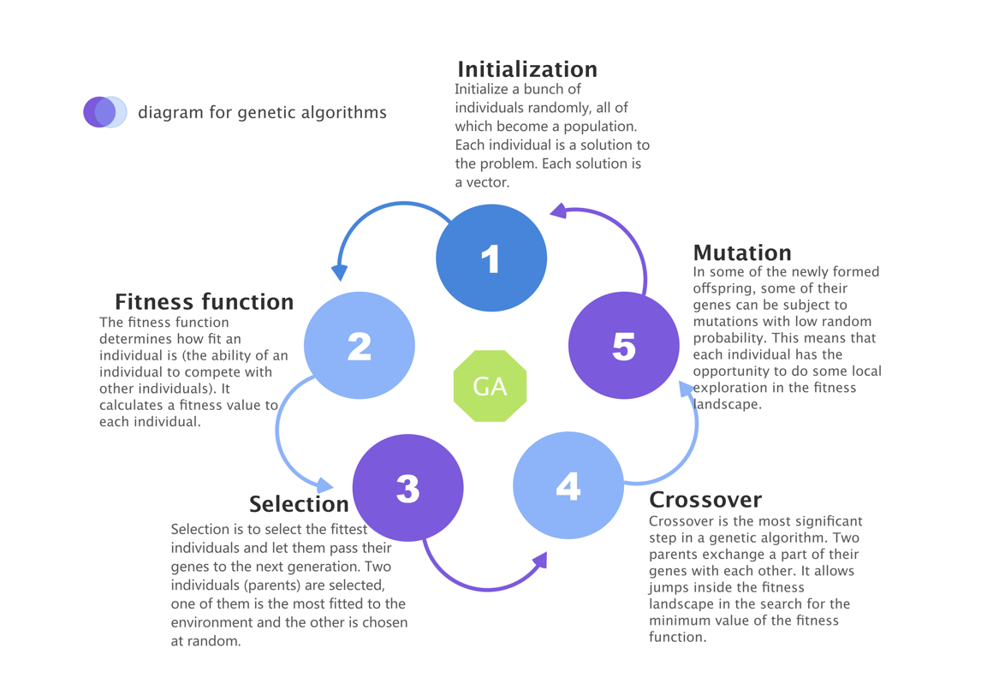

## Steady-state Genetic Algorithms

In every generation of Steady-state Genetic Algorithm, few are selected (good - with high fitness) chromosomes for creating a new offspring. Then some (bad - with low fitness) chromosomes are removed and the new offspring is placed in their place. The rest of population survives to new generation.[4]

In this summer project, the worst solution is removed and the only one new solution is added in each iteration. Only one solution is changed in each iteration.

The diagram for a general Steady-state Genetic Algorithm is shown in Figure 1-2.

Figure 1‑2

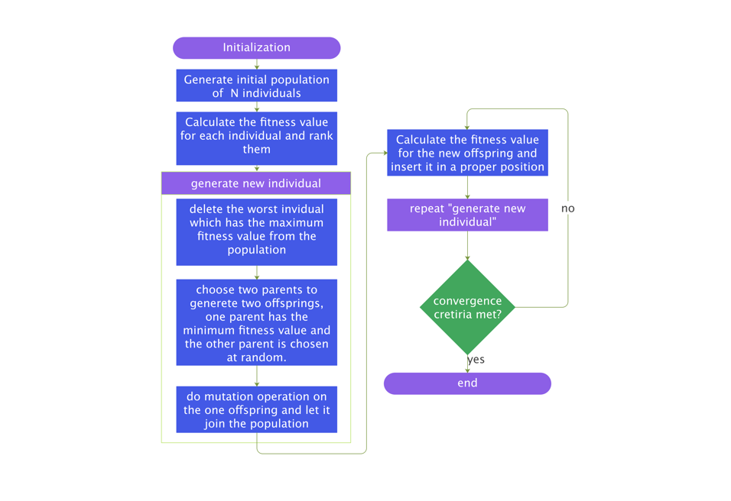

## Crossover

### singe-point-crossover

A point on both parents' chromosomes is picked randomly and designated a 'crossover point'. Bits to the right of that point are swapped between the two parent chromosomes. This results in two offspring, each carrying some genetic information from both parents.[5]

Figure 1-3 shows the process of single-point-crossover.

Figure 1‑3

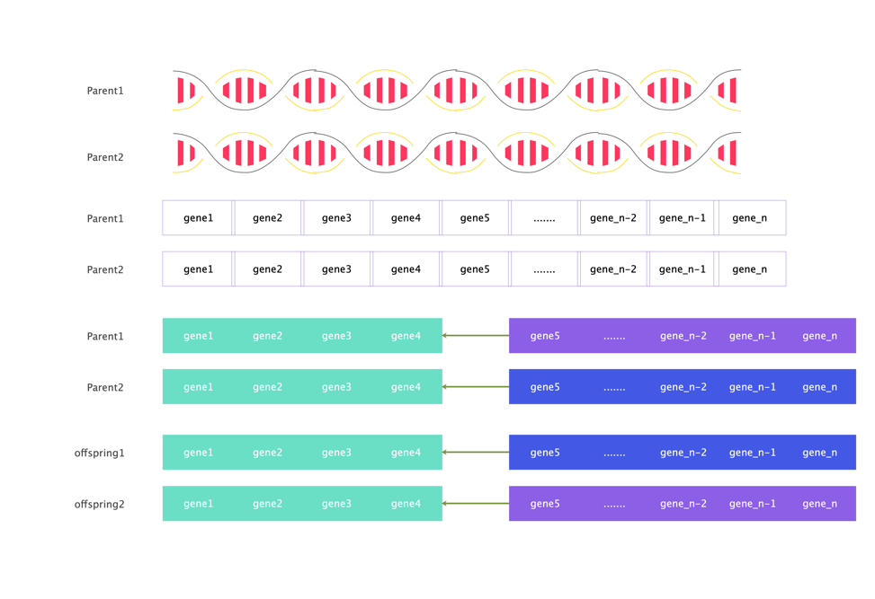

### Probabilistic crossover

Given a fixed crossover probability, for each gene, a random probability between 0 and 1 is generated. If the random probability is smaller than the crossover probability, then the gene at the corresponding position of the best individual is assigned to the offspring, and vice versa the gene at the corresponding position of the randomly selected individual is assigned to the offspring.

Let $P$ be a fixed crossover probability, let $x$ be a random probability, let $offspring_{i}$ be a position $i$ in the chromosome of offspring , $bestparent_{i}$ represents the corresponding gene of the best individual, $randomparent_{i}$ represents the corresponding gene of the random individual.

$offspring_{i}$ = $bestparent_{i}$ ($x<P$) + $randomparent_{i}$ ($x>P$)

Figure 1-4 shows the process of probabilistic crossover.

Figure 1‑4

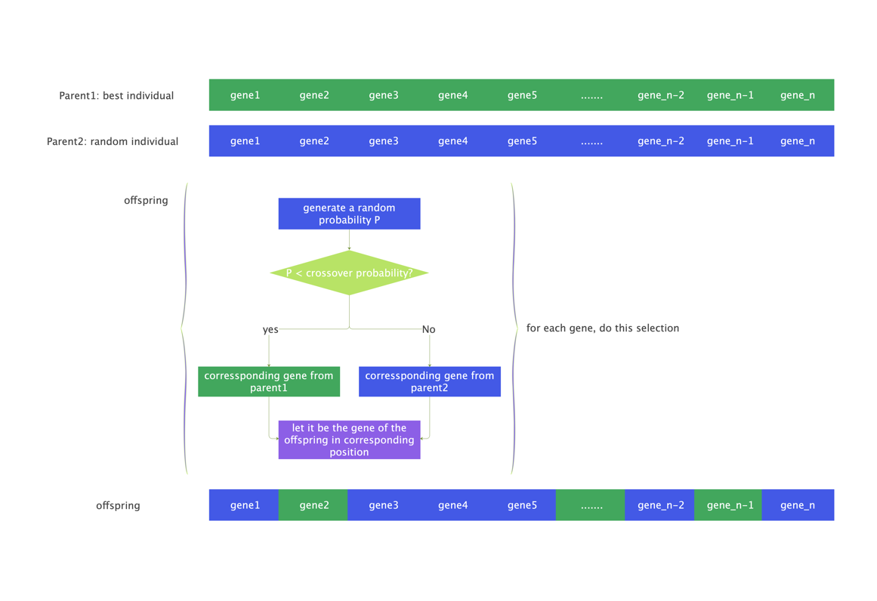

### Linear combination crossover

Given a fixed crossover probability $P$,let $offspring_{i}$ be a position $i$ in the chromosome of offspring, $bestparent_{i}$ represents the corresponding gene of the best individual, $randomparent_{i}$ represents the corresponding gene of the random individual.

$offspring_{i}$ = $bestparent_{i}$ $P$* + $randomparent_{i}$ $1-P$

*

Figure 1-5 shows the process of linear combination crossover.

Figure 1‑5

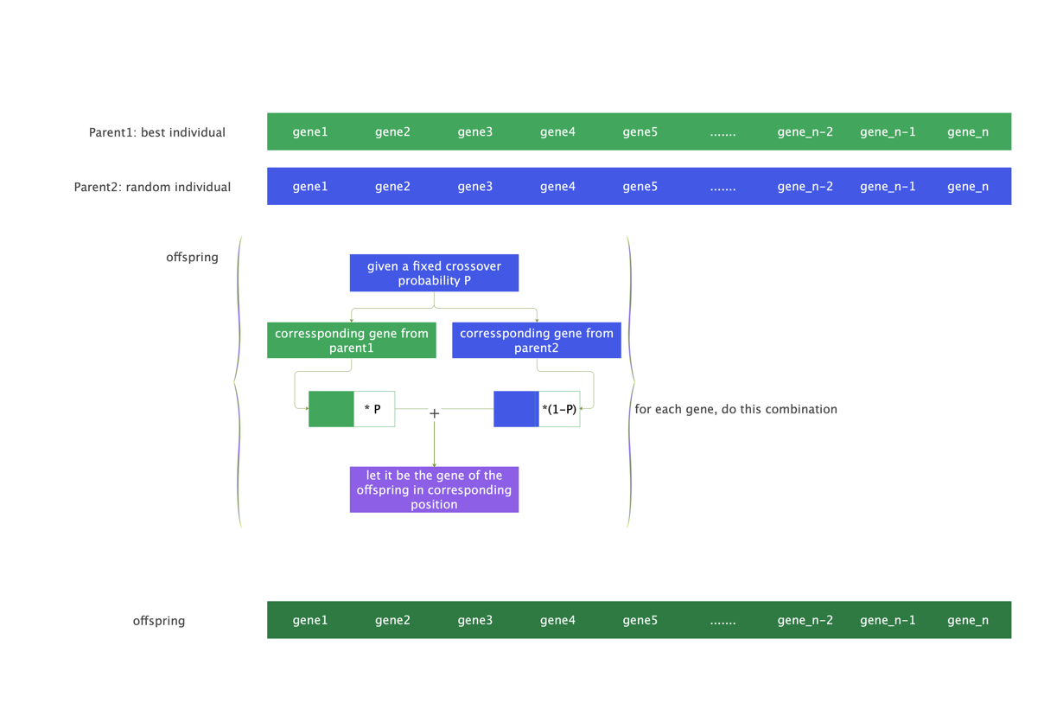

## Mutation

### uniform mutation

Given a fixed mutation rate $P$, a random probability $x$ and a fixed mutation range $W$,let $offspring_{i}$ be a position $i$ in the chromosome of offspring, let $result_{i}$ be a position $i$ in the result of crossover operation,

$offspring_{i}$ = $result_{i}$ $\left(x>P\right)$ +( $result_{i}$ + a **uniform distributed** random value generated from $\left[-W,W\right]$) $\left(x<P\right)$

### normal mutation

The probability density for the Gaussian distribution is

$p\left(x\right)=\frac{1}{\sqrt{2πσ^{2}}}e^{-\frac{{\left(x-μ\right)}^{2}}{2σ^{2}}}$ $\text{(25)}$

where $μ$ is the mean and $σ$ the standard deviation. The square of the standard deviation, $σ^{2}$, is called the variance.

Given a fixed mutation rate $P$, a random probability $x$ and a fixed mutation range $W$,let $offspring_{i}$ be a position $i$ in the chromosome of offspring, let $result_{i}$ be a position $i$ in the result of crossover operation,

$offspring_{i}$ = $result_{i}$ $\left(x>P\right)$ +( $result_{i}$ + (a **normal distributed** random value generated by giving $μ=0$ and $σ=2*W$) - $W$) $\left(x<P\right)$

## Baldwin effect and Lamarckian evolution

### Genotype and Phenotype

Individual has its own chromosome. Each chromosome has two representations. One is genotype: the set of genes representing the chromosome. The other one is phenotype: the actual physical representation of the chromosome.[6] In SSGA of this study, genotype and phenotype of individual are the same. In Baldwin and Lamarck algorithms, genotype and phenotype of individual are different.

### Local Search Procedures

Both of genotype and phenotype are solutions to a chosen test function. Phenotype is generated based on genotype by completing a local search procedure.

Given a genotype, a fixed local search rate $P$, a random probability $x$ and a fixed local search range $W$. Let $genotype_{i}$ be a position $i$ in the genotype. Let $phenotype_{i}$ be a position $i$ in the phenotype.

Uniform local search is,

$phenotype_{i}$ = $genotype_{i}$ $\left(x>P\right)$ + ( $genotype_{i}$ +a **uniform distributed** random value generated from $\left[-W,W\right]$) $\left(x<P\right)$

Normal local search is,

$phenotype_{i}$ = $genotype_{i}$ $\left(x>P\right)$ + ( $genotype_{i}$ +a **normal distributed** random value generated by giving $μ=0$ and $σ=2*W$ in Formula 25) - $W$) $\left(x<P\right)$

#### Baldwin effect

Compared with SSGA, Baldwin's algorithm has an additional local search procedure, this local search procedure is designed to generate phenotypes based on genotypes. The genotype and phenotype of individuals are different but same dimensional vectors. A phenotype of an individual is generated based on the genotype of the same individual by using one of local search procedures.

In SSGA, the genotype and phenotype of an individual is the same. There is no difference to use genotype or phenotype to produce offspring since they are the same. Baldwin offspring are generated based on genotypes of the parents selected among the population.

#### Lamarckian evolution

In Lamarck algorithm of this study, offspring are generated based on phenotypes of the parents selected among the population, the other parts are the same as Baldwin algorithm

## Evolutionary Algorithms

### SSGA

Figure 1-6 shows the whole process for SSGA.

Figure 1‑6

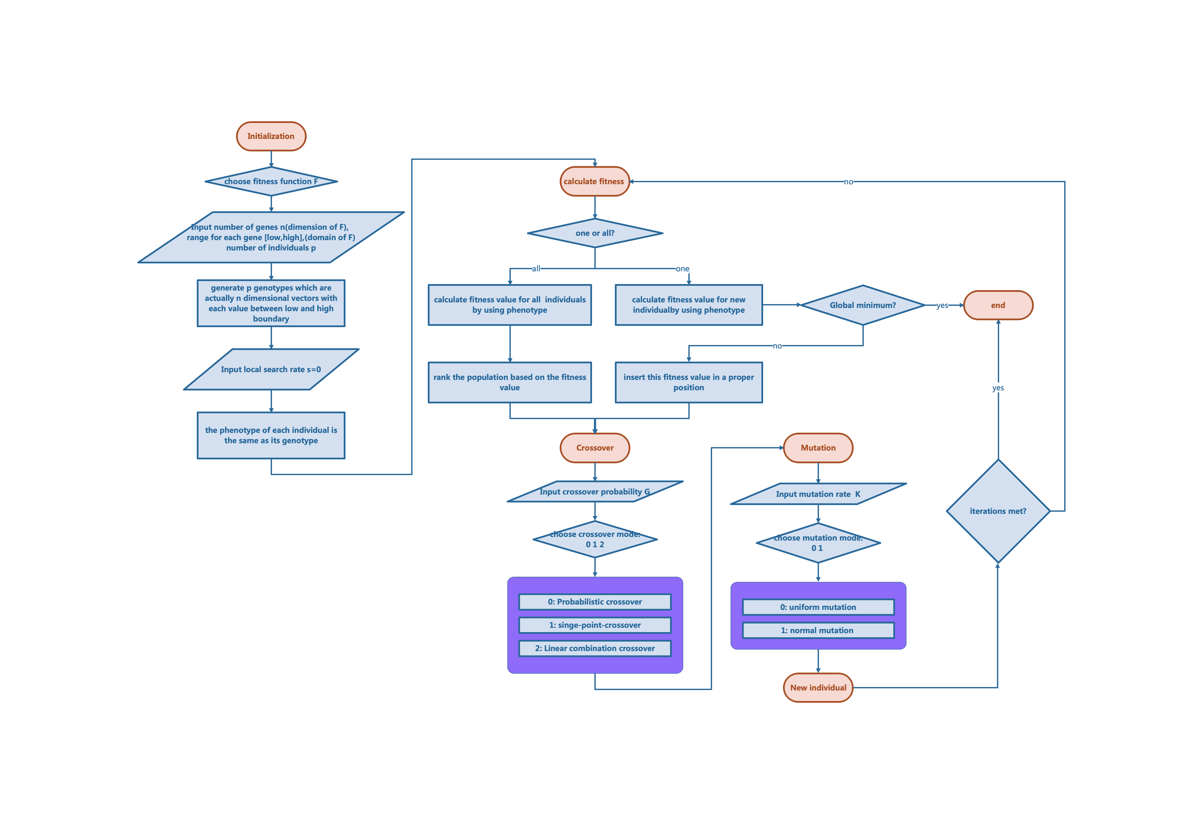

### Baldwin algorithm vs Lamarck algorithm

Figure 1-7 shows the whole process for Baldwin algorithm vs Lamarck algorithm.

Figure 1‑7

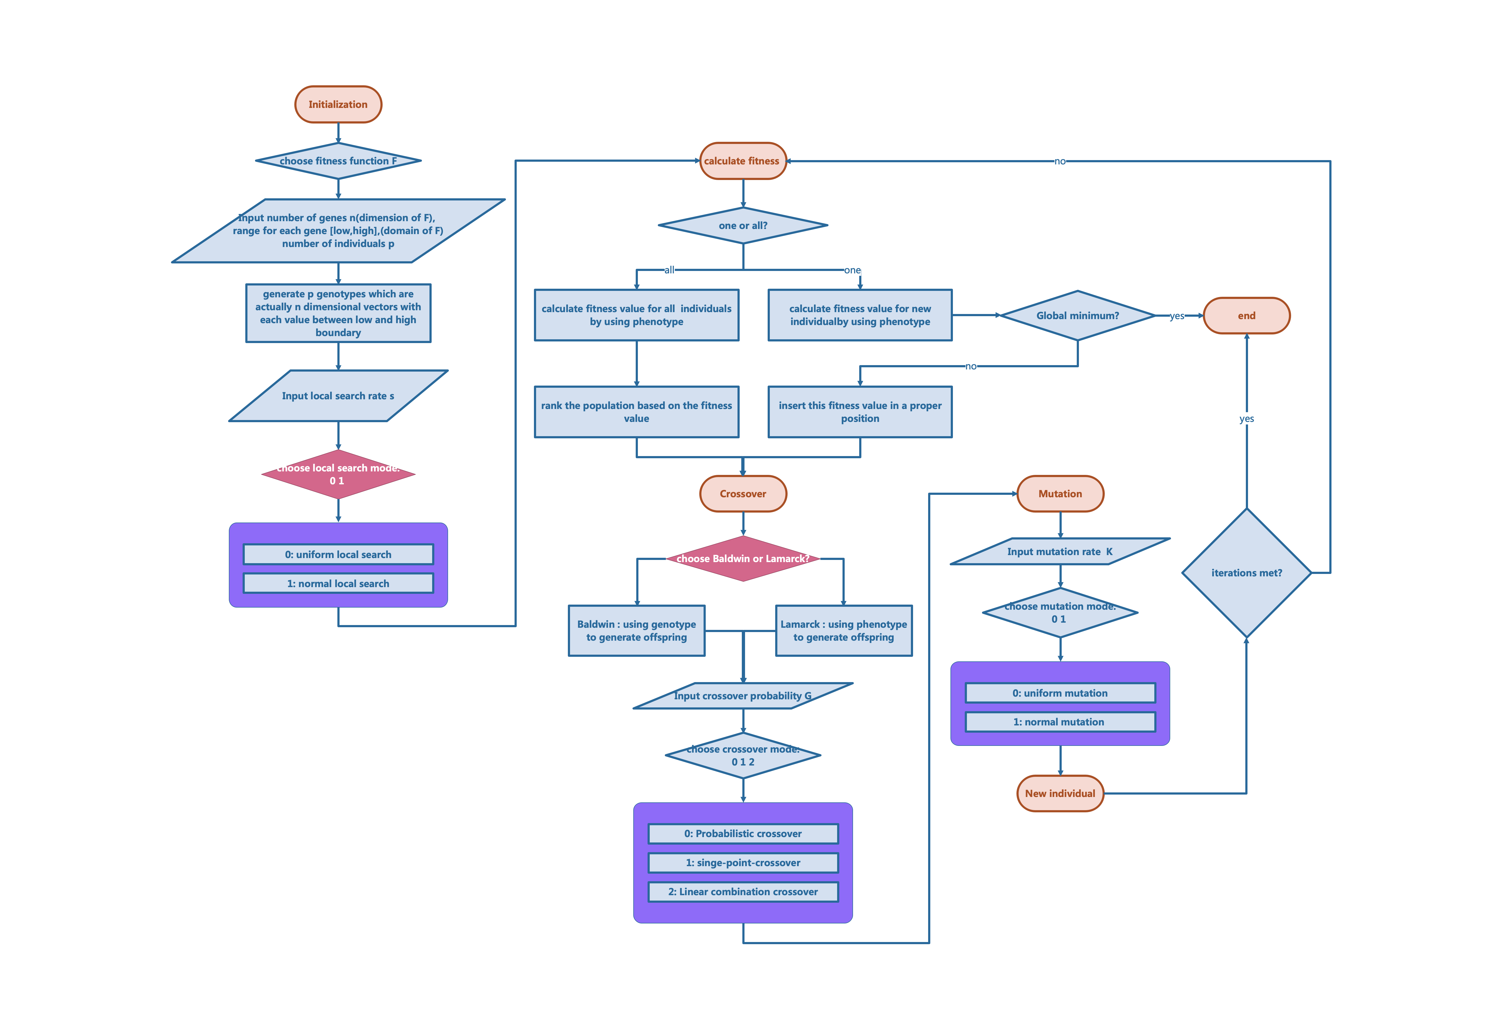

# Exploration on parameters

We want to find the global minimums of the test function group CEC-BC- 2017 by using evolutionary algorithms and examine the importance of local search parts in Baldwin and Lamarck compared to SSGA.

So far, we did 6 experiments in total.

In Experiment 1, we chose a sequence for each parameter and then made different combinations of these values, running each combination of parameters 10 times for max, min, std, and mean. The code for Experiment 1 contains only Baldwin and Lamarck, and the crossover type is only single point crossover, and the mutation type is only uniform mutation. In Experiment 1 we ran all 23 functions.

Based on Experiment 1, we did Experiment 2. In Experiment 2, we modified the sequence value for each parameter. And added a parameter called crossover probability. The code for Experiment 2 contains only Baldwin and Lamarck, and the crossover type is only single point crossover, and the mutation type is only uniform mutation. In Experiment 1 we ran only ran F1 for Baldwin algorithm.

Based on Experiment 2, we did Experiment 3. In Experiment 3, we modified the sequence value for each parameter again. The code for Experiment 3 contains only Baldwin and Lamarck, and the crossover type is only single point crossover, and the mutation type is only uniform mutation. In Experiment 3 we ran only ran F1 for Baldwin algorithm and F22 for Lamarck algorithm.

The results of the above 3 Experiments didn’t meet our expectations.

In Experiment 4, Here we implemented SSGA and added the new types of crossover. We decreased the dimensionality, to make sure that we can quickly find the best combination of parameters. SSGA contains 3 types for crossover and 2 types for mutation. Based on the results of Experiment 4, we saved the best 20 parameter combinations. In Experiment 4 we ran only ran F1, F3, F6, F12, F18 and F22 for SSGA.

Based on the best 20 parameter combinations obtained in Experiment 4, we did Experiment 5.  
We ran the best 20 parameter combinations for all the functions and changed the dimensions to original dimensions. SSGA performs well in certain functions. In Experiment 5 we ran all 23 functions.

In Experiment 6, we implemented two local search procedures. The difference between Lamarck/Baldwin and SSGA is the local search part. We want to improve SSGA by the local search procedures. In Experiment 6 we ran all 23 functions.

## Experiment1

Table 2-1 shows the environment for Experiment1.

Table 2‑1

| Experiment1 | Setting |
| --- | --- |
| Algorithm | Lamarck, Baldwin |
| Functions tested | All the functions |
| Number of parameters | 6 |
| Crossover type | Single point crossover |
| Mutation type | Uniform |
| Local search type | Uniform |
| Multiple runs | 10 |

Table 2-2 shows the name of each parameter and the sequence for exploration for Experiment 1.

Table 2‑2

| Name of parameter | Sequence for parameter |
| --- | --- |
| iterations | [500, 1000, 2000, 3000] |
| mutation rate | [0.1, 0.5, 1.0, 2.0] |
| local search | [0.1, 0.5, 1.0, 2.0] |
| num individuals | [50, 100, 150] |
| m range | [0.5, 1.0, 2.0, 5.0] |
| range mutation | [0.5, 1.0, 2.0, 5.0] |

local search is the rate for the local search part. num individuals is the number of individuals. m range is the range for local search. range mutation is the range for mutation.

Number of parameter combination = 4*4*4*3*4*4 = 3072

### Data visualization

#### Fitness plot for Experiment1

The percentage table shows the ability for each function to find the global minimum given a parameter combination. It should be 23 rows * 3072 columns.

We create a plot for each function to see the overall fitness value tested on 3072 parameter combinations.

Figure 2-1 to Figure 2-23 show the fitness performance of functions F1 to F23, separately, for these parameters given in Experiment 1.

The x axis represents parameter combination from 1 to 3072. The y axis represents the fitness value, each parameter combination has been run 10 times. Orange color represents the results for Baldwin algorithm, while blue color represents the results for Lamarck algorithm.

Figure 2‑1_F1

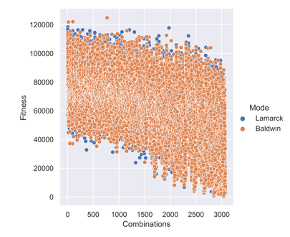

Figure 2‑2_F2

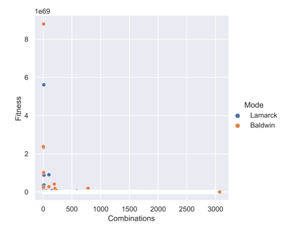

Figure 2‑3_F3

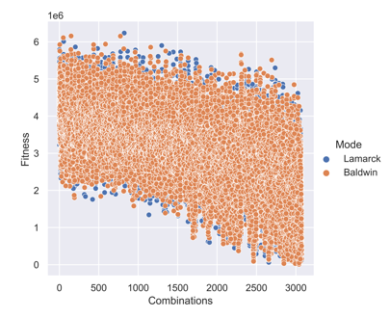

Figure 2‑4_F4

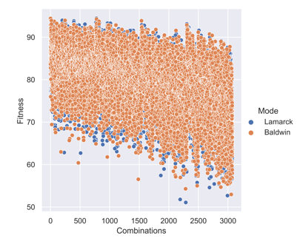

Figure 2‑5_F5

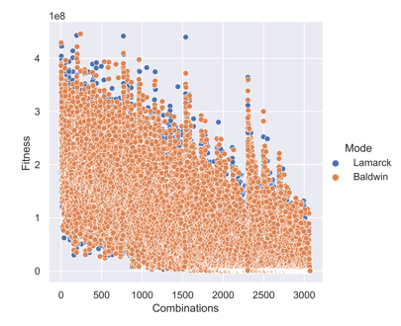

Figure 2‑6_F6

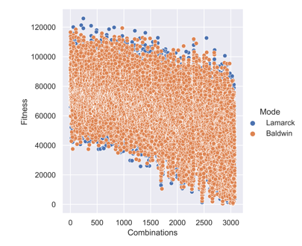

Figure 2‑7_F7

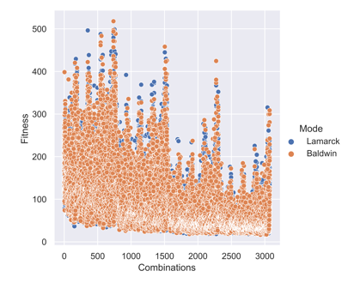

Figure 2‑8_F8

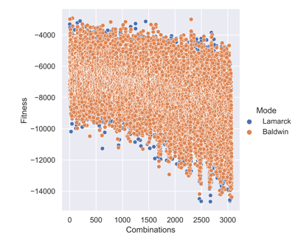

Figure 2‑9_F9

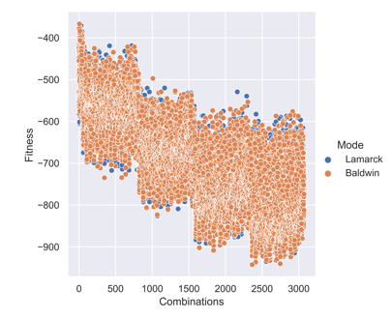

Figure 2‑10_F10

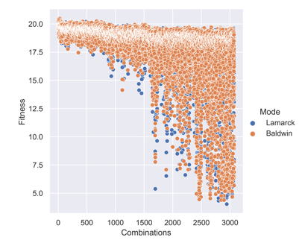

Figure 2‑11_F11

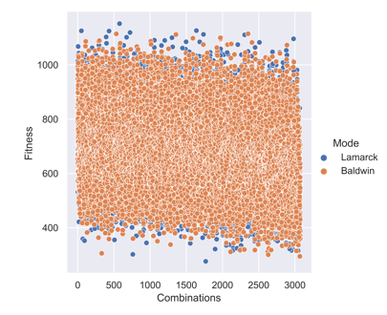

Figure 2‑12_F12

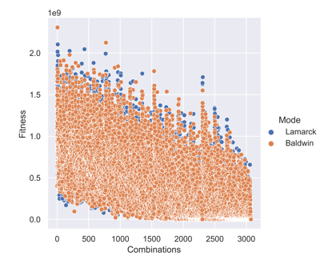

Figure 2‑13_F13

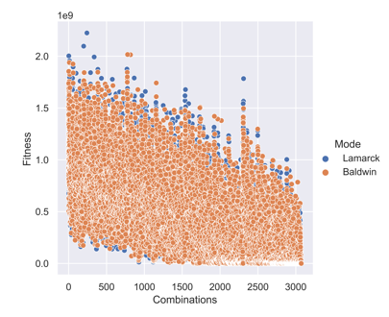

Figure 2‑14_F14

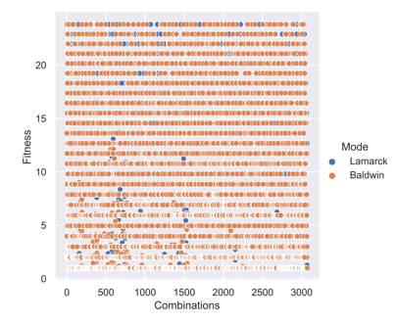

Figure 2‑15_F15

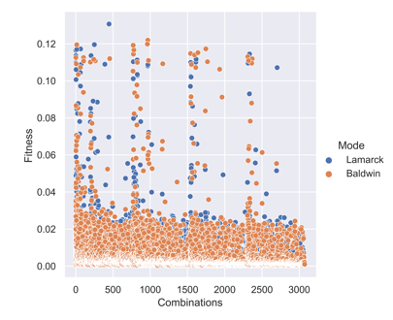

Figure 2‑16_F16

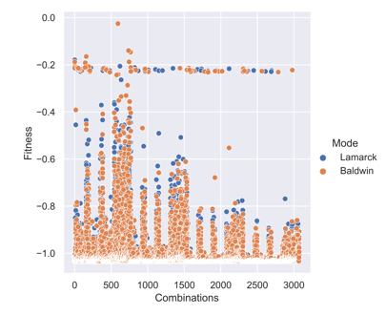

Figure 2‑17_F17

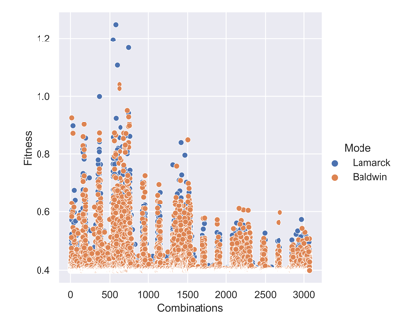

Figure 2‑18_F18

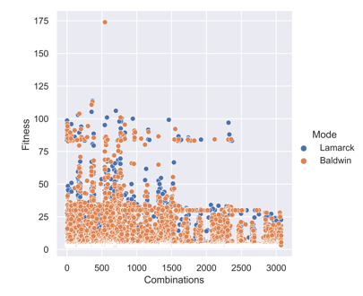

Figure 2‑19_F19

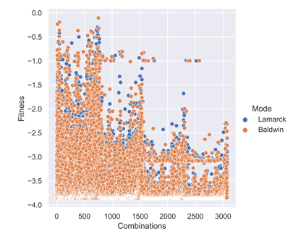

Figure 2‑20_F20

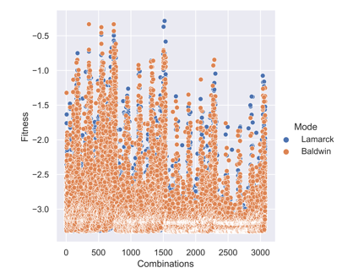

Figure 2‑21_F21

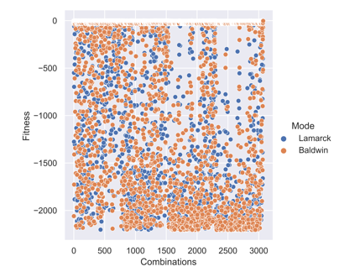

Figure 2‑22_F22

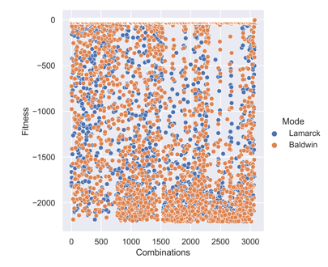

Figure 2‑23_F23

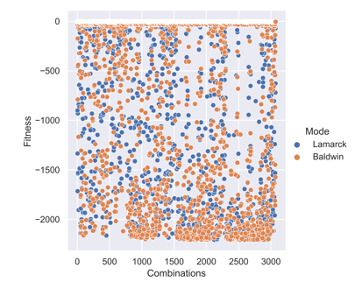

#### Percentage plot for Experiment1

Figure 2-24 to Figure 2-46 show the percentage performance of functions F1 to F23, separately, for these parameters given in Experiment 1.

The x axis represents parameter combination from 1 to 3072. The y axis represents the percentage value showing the number of times that global minima has been found among 10 runs, each parameter combination has been run 10 times. Orange color represents the results for Baldwin algorithm, while blue color represents the results for Lamarck algorithm.

Figure 2‑24_F1

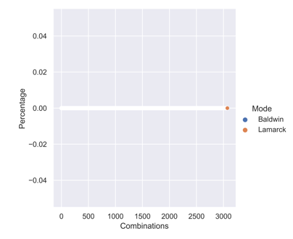

Figure 2‑25_F2

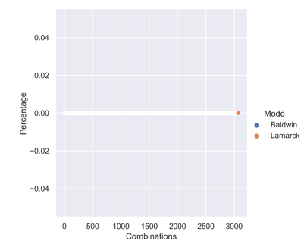

Figure 2‑26_F3



Figure 2‑27_F4



Figure 2‑28_F5



Figure 2‑29_F6



Figure 2‑30_F7



Figure 2‑31_F8



Figure 2‑32_F9

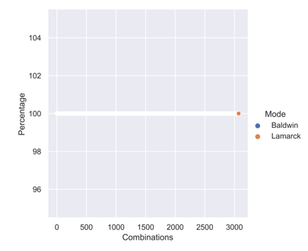

Figure 2‑33_F10



Figure 2‑34_F11



Figure 2‑35_F12



Figure 2‑36_F13



Figure 2‑37_F14

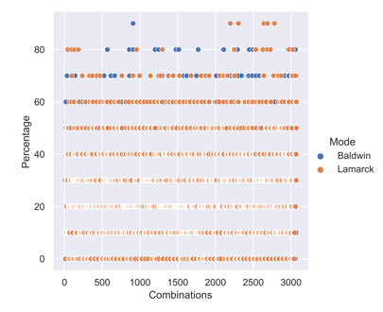

Figure 2‑38_F15

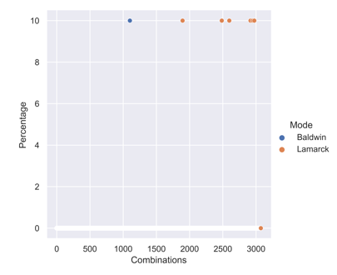

Figure 2‑39_F16

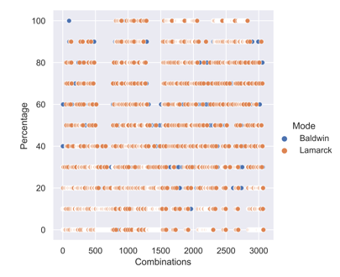

Figure 2‑40_F17

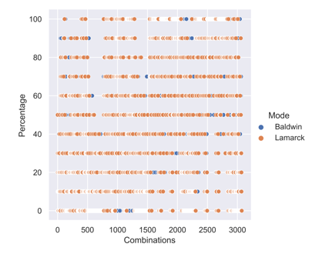

Figure 2‑41_F18

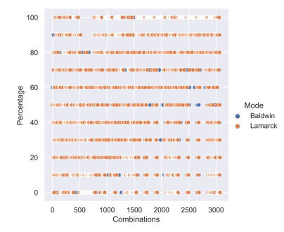

Figure 2‑42_F19

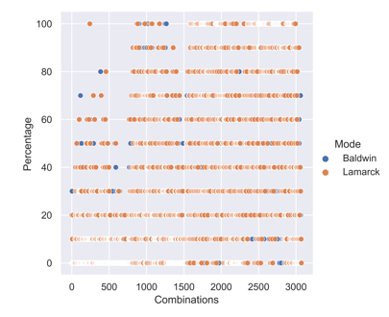

Figure 2‑43_F20

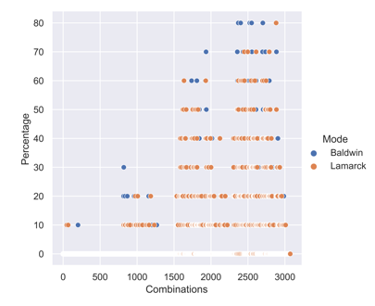

Figure 2‑44_F21

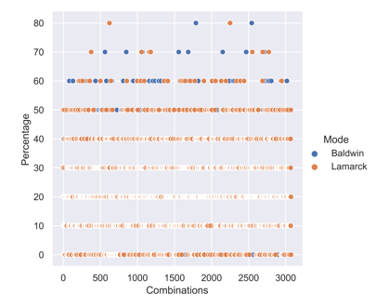

Figure 2‑45_F22

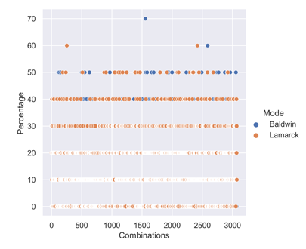

Figure 2‑46_F23

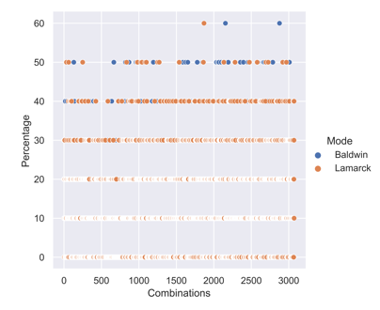

#### Violin plot for parameter exploration

Our main goal is to find good parameters, so we need to do some analysis using violin plots to see how the value of each parameter affects the algorithm.

Figure 2-47 to Figure 2-69 show the influence of each value in a parameter sequence for functions F1 to F23, separately. The subplots in each figure are corresponding to the parameters. The x axis for each subplot is the actual value for a parameter. The y axis is the fitness value. Orange color represents Baldwin algorithm, while green color represents Lamarck algorithm.  
For example, from left to right, from upper to down, Figure 2-47 shows violin plots for parameter “iterations”, “mutation rate”, “local search”,” num individuals”, “m range”, “range mutation”, separately. The x axis for each subplot is the sequence for each parameter and the y axis is the corresponding fitness value. One can notice that there are 3 horizontal lines in each plot which represents Q1, Q2 and Q3.

Figure 2‑47_F1

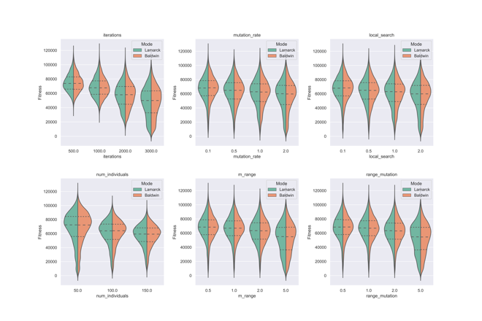

Figure 2‑48_F2

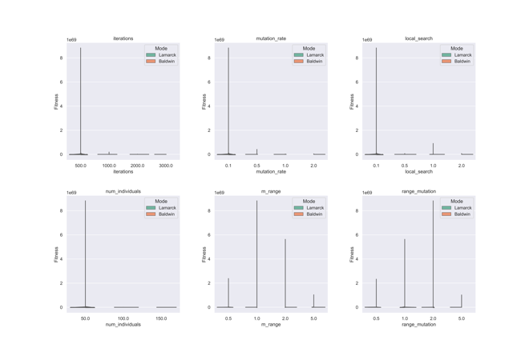

Figure 2‑49_F3

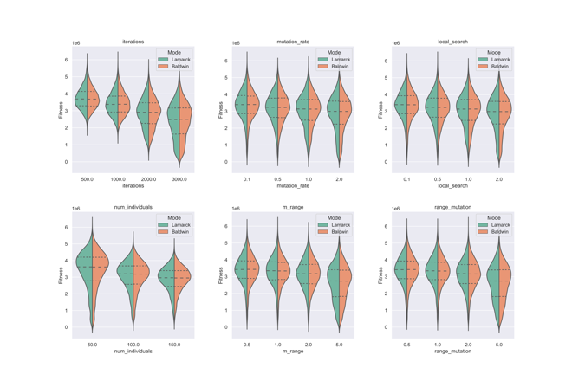

Figure 2‑50_F4

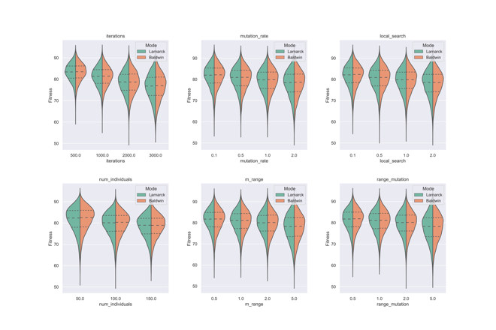

Figure 2‑51_F5

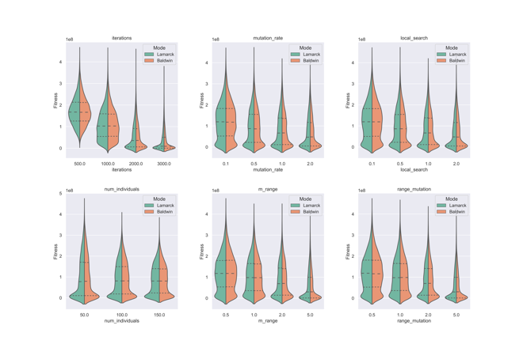

Figure 2‑52_F6

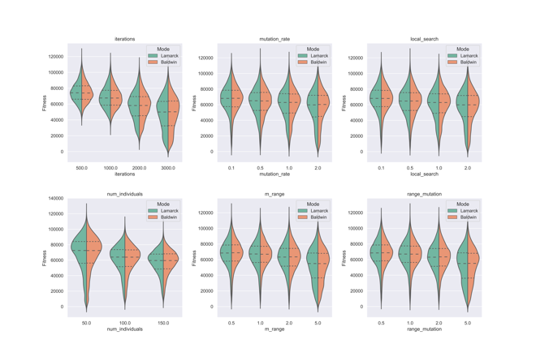

Figure 2‑53_F7

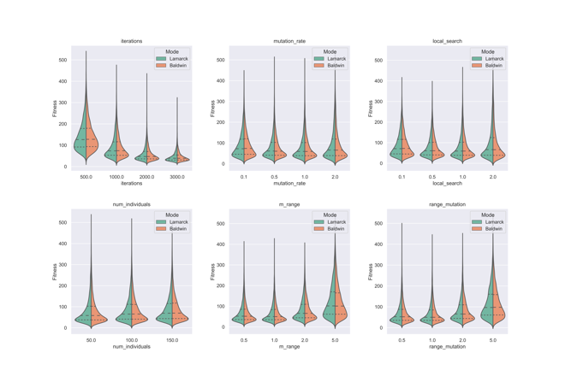

Figure 2‑54_F8

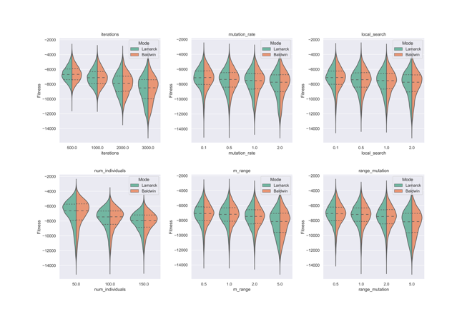

Figure 2‑55_F9

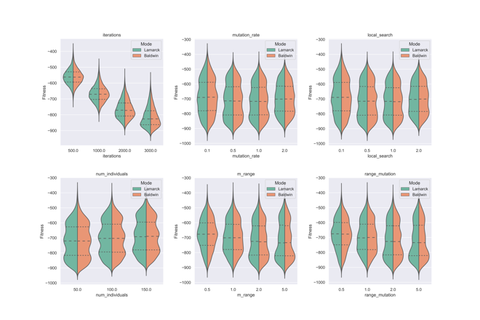

Figure 2‑56_F10

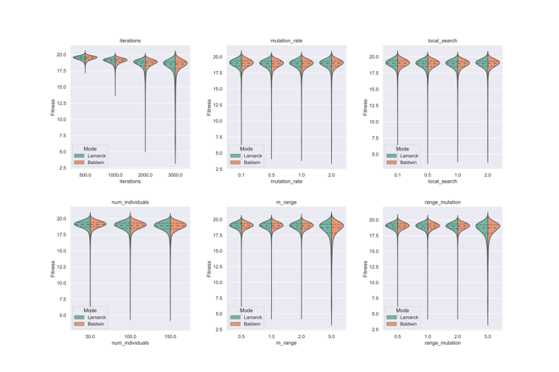

Figure 2‑57_F11

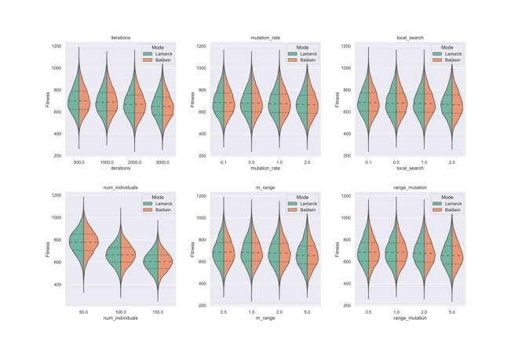

Figure 2‑58_F12

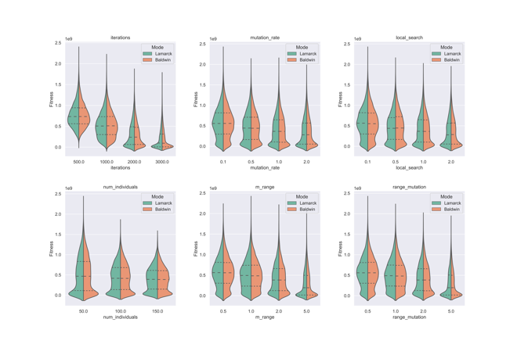

Figure 2‑59_F13

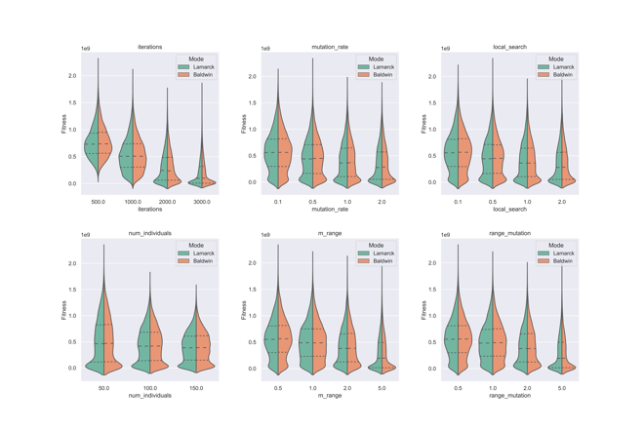

Figure 2‑60_F14

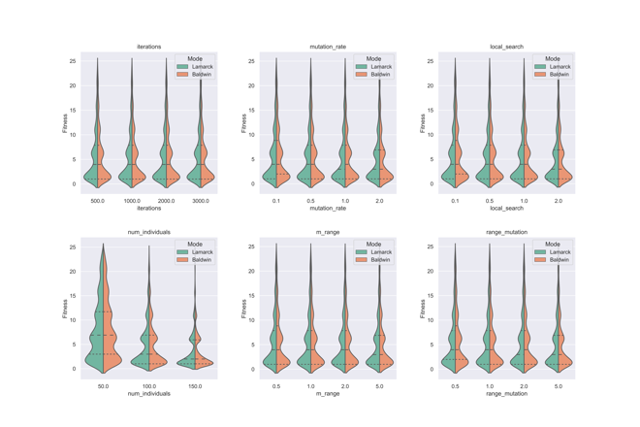

Figure 2‑61_F15

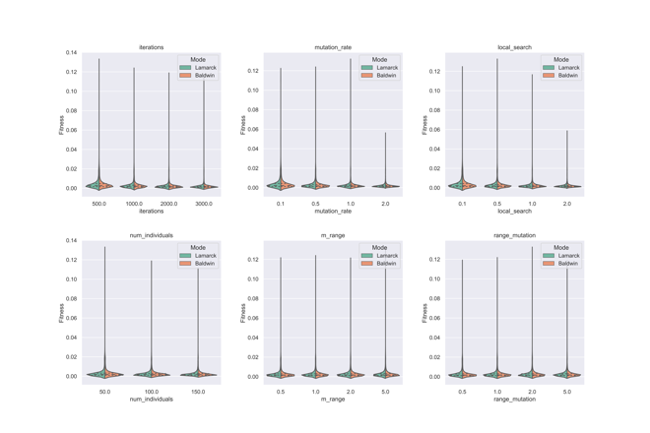

Figure 2‑62_F16

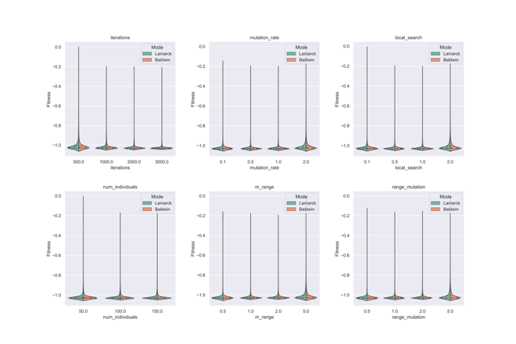

Figure 2‑63_F17

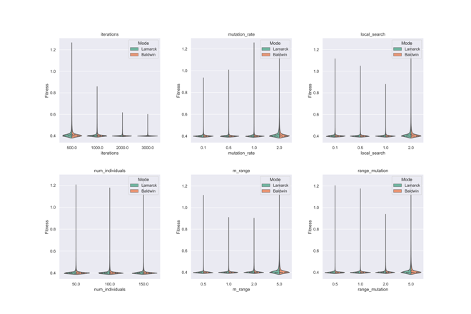

Figure 2‑64_F18

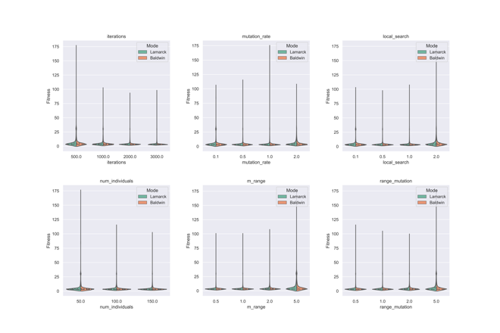

Figure 2‑65_F19

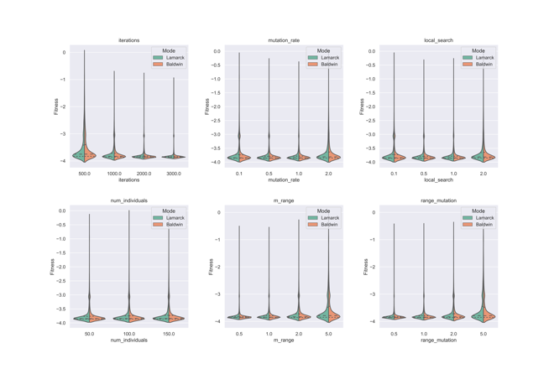

Figure 2‑66_F20

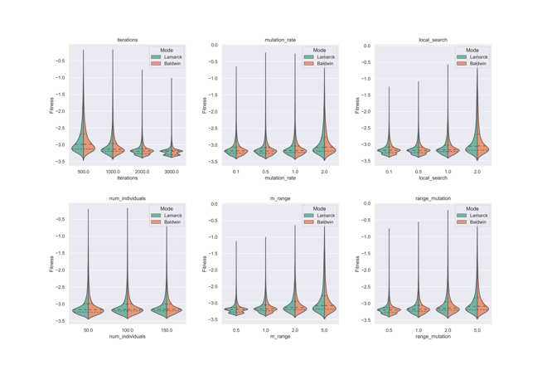

Figure 2‑67_F21

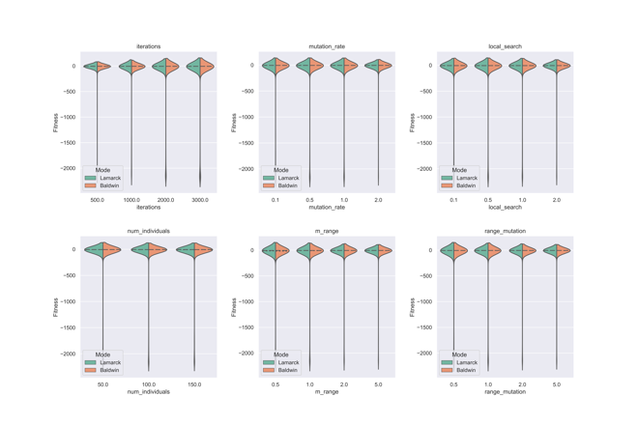

Figure 2‑68_F22

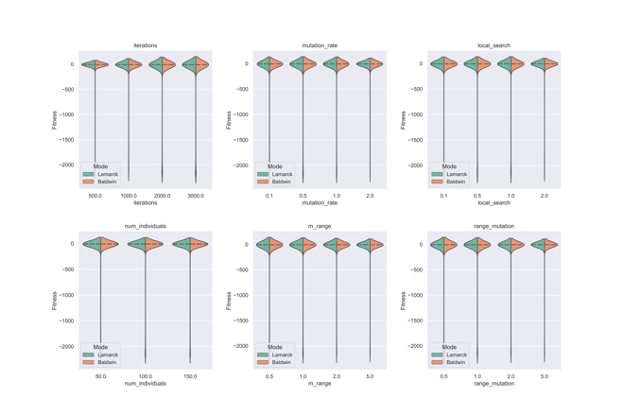

Figure 2‑69_F23

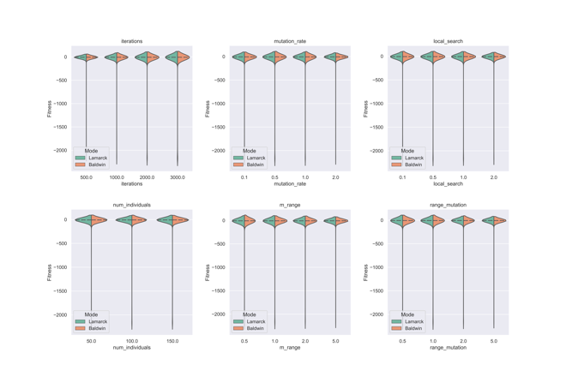

### Conclusion of Experiment 1

For fitness plots:

1. With a total of 3072 parameter combinations, basically all figures show a clear downward trend. I think this is mainly because the closer you get to the 3072, the higher the number of iterations the algorithm performs, so the result found is smaller than the previous one. Of course, we cannot ignore the effect of the other parameters combined.
2. There is clearly something wrong with F9 somewhere. Because the global minima of F9 is zero, but the solutions of F9 are basically smaller than the global minima. Later I found the reason is that in each iteration, the new individual generated after mutation has not been checked with domain limitation. The problem that not doing domain-checking does not affect all functions. For example, if the test function is chosen from one of the unimodal functions like F1 to F7, no matter what the domain is, it will never find a solution which is lower than the minima.   
   F21, F22 and f23 have the same problem that some solutions are even lower than the minima.
3. The figures show that F5, F13, F15, F16, F17, F18, F19, F20 converge faster than the others.

For percentage plots:

1. The code for this experiment did not perform domain checking on the new individuals after each generation, which resulted in some functions finding a minimum value smaller than the given global minimum. This directly makes the results of the percentage table not accurate for multinomial functions and the probability of successfully finding the minimum value is higher than the actual situation.
2. **Percentage plots in Experiment1 are meaningless because of not doing domain checking.**

For violin plots:

1. As the number of iterations or number of individuals increases, the minimum value that can be found is smaller and smaller, with a clearer downward trend. This conclusion is correct, although this experiment did not do domain checking.
2. For several other parameters, the solutions are getting smaller as the value increases, but the change is not significant.
3. For some functions, however, the downward trend is small or barely noticeable.
4. Lamarck is slightly better than Baldwin.

In fact, the probability of producing an invalid gene is very small for high dimensional functions with a wide domain.

The reason is that the probability of a new gene arising in the population is very low (mutation rate* dimension = number of new genes will be generated), and the new gene will only appear in the population when there is a mutation operation. The mutation rate and the range of mutation given by us are very low, so the probability of new genes not within the domain is low.

Another reason is that our goal is to find the minimum value, and each time we choose the minimum solution to generate offspring, as the number of iterations increases, the solution gets smaller and smaller, i.e., it gets closer to the middle of the domain, if the domain is [-100, 100], in many cases the minimum value is probably at 0. An invalid gene is not in the domain, i.e., it exceeds the upper and lower limits of the domain. Logically, it is also difficult for high dimensional functions with a wide domain to produce invalid genes.

## Experiment2

Table 2-3 shows the environment for Experiment2.

Table 2‑3

| Experiment2 | Setting |
| --- | --- |
| Algorithm | Baldwin |
| Functions tested | F1 |
| Number of parameters | 7 |
| Crossover type | Single point crossover |
| Mutation type | Uniform |
| Local search type | Uniform |
| Multiple runs | 10 |

Table 2-4 shows the name of each parameter and the sequence for exploration for Experiment 2.

Table 2‑4

| Name of parameter | Sequence for parameter |
| --- | --- |
| iterations | [50, 600, 1500, 3000, 6500, 10000] |
| mutation rate | [0.001, 0.02, 0.04, 0.06, 0.08, 0.1, 0.18, 0.2] |
| local search | [0.04, 2.0] |
| num individuals | [50, 100, 150, 200, 250, 300, 350, 400] |
| m range | [5, 75] |
| range mutation | [20, 80] |
| Crossover probability | [0.5,0.9] |

local search is the rate for the local search part. num individuals is the number of individuals. m range is the range for local search. range mutation is the range for mutation.

Number of parameter combination = 6*8*2*8*2*2*2= 6144

Of all the solutions, the min value is 49.726447. and the corresponding parameter combination is **[10000.0,0.08,2.0,50.0,5.0,20.0,0.9]**. The global minima is zero. It is not necessary to generate percentage table for this experiment since that none of the solution generated by 6144 parameter combinations find the global minima.

Figure 2-70 shows the violin plot for Experiment2. From left to right, from upper to down, Figure 2-70 shows violin plots for parameter “iterations”, “mutation rate”, “local search”,” num individuals”, “m range”, “range mutation”, “crossover probability”, separately. The x axis for each subplot is the sequence for each parameter and the y axis is the corresponding fitness value. One can notice that there are 3 horizontal lines in each plot which represents Q1, Q2 and Q3.

Figure 2‑70

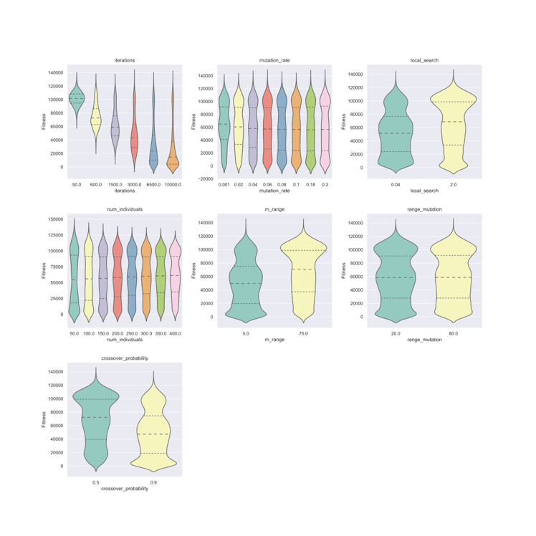

### Conclusion of Experiment 2

1. As the number of iterations increases, the solutions become significantly smaller and smaller.
2. Performance of crossover probability: 0.9>0.5
3. The other parameters do not show up as obvious changes.

## Experiment3

Table 2-5 shows the environment for Experiment3.

Table 2‑5

| Experiment3 | Setting |
| --- | --- |
| Algorithm | Baldwin, Lamarck |
| Functions tested | F1, F22 |
| Number of parameters | 7 |
| Crossover type | Single point crossover |
| Mutation type | Uniform |
| Local search type | Uniform |
| Multiple runs | 10 |

Table 2-6 shows the name of each parameter and the sequence for exploration for Experiment 3.

Table 2‑6

| Name of parameter | Sequence for parameter |
| --- | --- |
| iterations | [10000] |
| mutation rate | [5.0, 10.0] |
| local search | [0.01, 1.0, 5.0] |
| num individuals | [50, 400, 800] |
| m range | [0.05, 0.35, 0.8, 1.2] |
| range mutation | [0.01, 0.25, 0.55, 0.9] |
| Crossover probability | [0.4, 1.0] |

Number of parameter combination = 1*2*3*3*4*4*2 = 576. Of all the solutions, the min value of F1using Baldwin is 3.406007(minima is 0). and the corresponding parameter combination is **[10000.0,10.0,0.01,50.0,1.2,0.9,1.0]**.

Figure 2-71 shows the violin plot for F1 with Baldwin.

From left to right, from upper to down, Figure 2-71 shows violin plots for parameter “iterations”, “mutation rate”, “local search”,” num individuals”, “m range”, “range mutation”, “crossover probability”, separately. The x axis for each subplot is the sequence for each parameter and the y axis is the corresponding fitness value. One can notice that there are 3 horizontal lines in each plot which represents Q1, Q2 and Q3.

Figure 2‑71

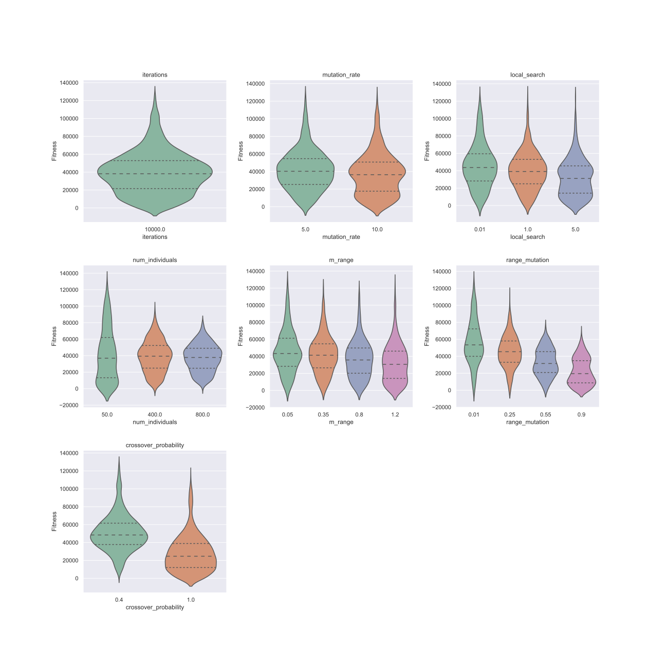

Of all the solutions, the min value of F22 using Lamarck is -10.402907(minima is -10.4028), the corresponding parameter combination is **[10000.0,10.0,1.0,800.0,0.05,0.01,1.0]**.

Figure 2-72 shows the violin plot for F22 with Lamarck.

From left to right, from upper to down, Figure 2-72 shows violin plots for parameter “iterations”, “mutation rate”, “local search”,” num individuals”, “m range”, “range mutation”, “crossover probability”, separately. The x axis for each subplot is the sequence for each parameter and the y axis is the corresponding fitness value. One can notice that there are 3 horizontal lines in each plot which represents Q1, Q2 and Q3.

Figure 2‑72

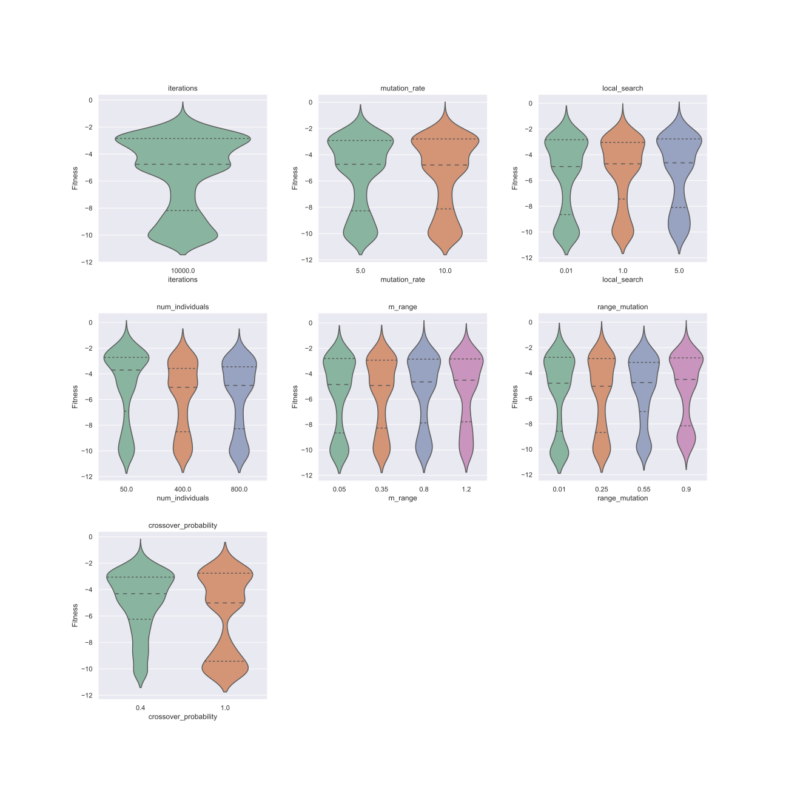

### Conclusion of Experiment 3

1. With 10,000 iterations, it is possible to find the minimum value.
2. Given the sequence for mutation range in this experiment, the effect on F1 and similar functions is obvious, with solutions showing a clear downward trend.

## Experiment4: SSGA in 10 dimensions

Table 2-7 shows the environment for Experiment4.

Table 2‑7

| Experiment4 | Setting |
| --- | --- |
| Algorithm | SSGA |
| Functions tested | F1, F3, F6, F12, F18, F22 |
| Number of parameters | 5 |
| Crossover type | Single point crossover probabilistic crossover linear combination crossover |
| Mutation type | Uniform Normal |
| Multiple runs  Dimensions | 10  10 |

Table 2-8 shows the name of each parameter and the sequence for exploration for Experiment 3.

Table 2‑8

| Name of parameter | Sequence for parameter |
| --- | --- |
| iterations | [1000000] |
| mutation rate | [0.1, 0.18, 0.2, 0.5, 1.0, 2.0, 5.0, 10.0] |
| num individuals | [100, 200] |
| range mutation | [0.01, 0.25, 0.55, 0.9, 2.0, 5.0] |
| crossover probability | [0.5, 0.6, 0.7] |

Number of parameter combination = 1*8*2*6*3= 288. Since the number of iterations was one million, we only ran **200/288**.

### Scatter plots

Figure 2-73 to Figure 2-78 show the percentage result for F1, F3, F6, F12, F18 and F22 separately.

Figure 2-73 shows SSGA for F1 in 10 dimensions. The x axis is the index for parameter combination, the y axis is percentage value showing the number of times that global minima has been found among 10 runs. The x axis ranges from 1 to 200 which corresponds to the 1 to 200 parameter combination in this experiment. The y axis ranges from 0 to 100.

Figure 2‑73

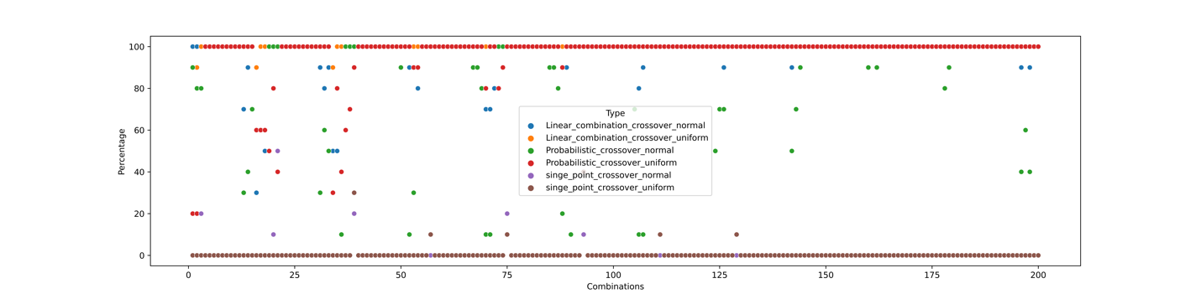

Figure 2-74 shows SSGA for F3 in 10 dimensions. The x axis is the index for parameter combination, the y axis is percentage value showing the number of times that global minima has been found among 10 runs. The x axis ranges from 1 to 200 which corresponds to the 1 to 200 parameter combination in this experiment. The y axis ranges from 0 to 100.

Figure 2‑74

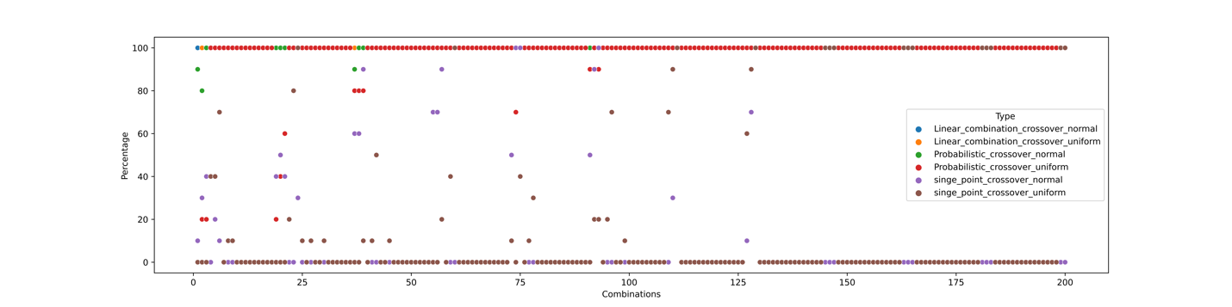

Figure 2-75 shows SSGA for F6 in 10 dimensions. The x axis is the index for parameter combination, the y axis is percentage value showing the number of times that global minima has been found among 10 runs. The x axis ranges from 1 to 200 which corresponds to the 1 to 200 parameter combination in this experiment. The y axis ranges from 0 to 100.

Figure 2‑75

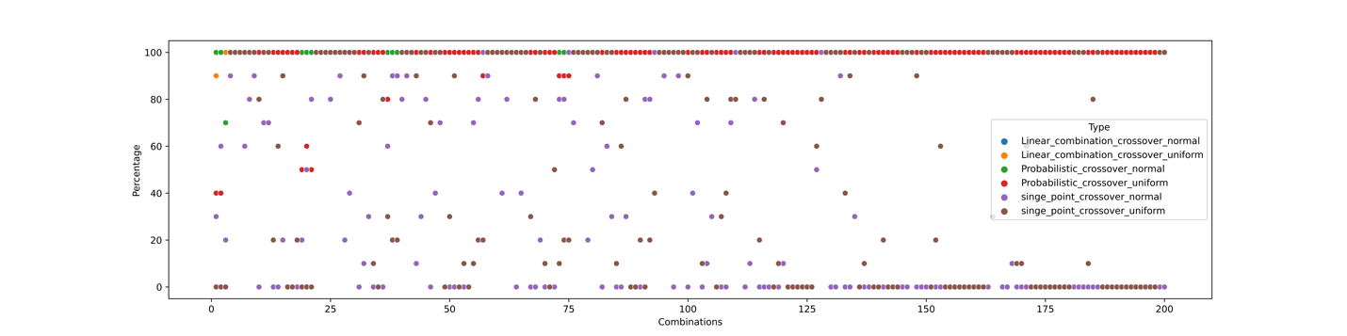

Figure 2-76 shows SSGA for F12 in 10 dimensions. The x axis is the index for parameter combination, the y axis is percentage value showing the number of times that global minima has been found among 10 runs. The x axis ranges from 1 to 200 which corresponds to the 1 to 200 parameter combination in this experiment. The y axis ranges from 0 to 100.

Figure 2‑76

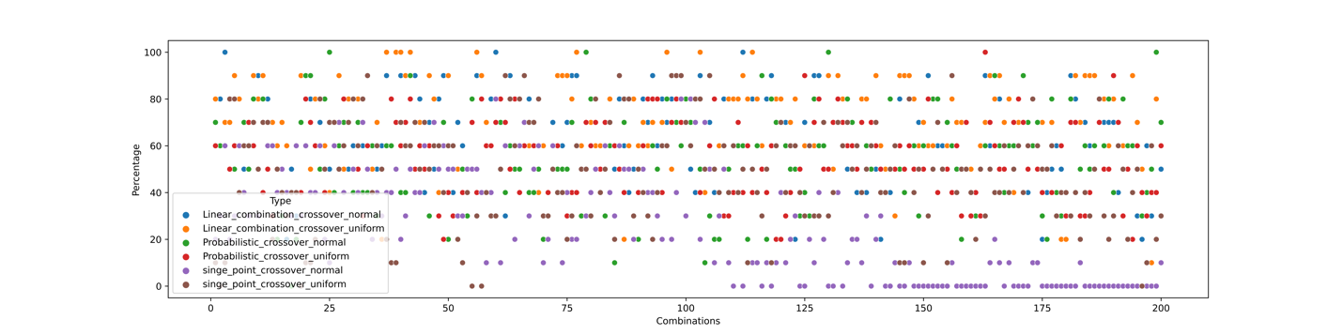

Figure 2-77 shows SSGA for F18 in Experiment4. The x axis is the index for parameter combination, the y axis is percentage value showing the number of times that global minima has been found among 10 runs. The x axis ranges from 1 to 200 which corresponds to the 1 to 200 parameter combination in this experiment. The y axis ranges from 0 to 100.

Figure 2‑77

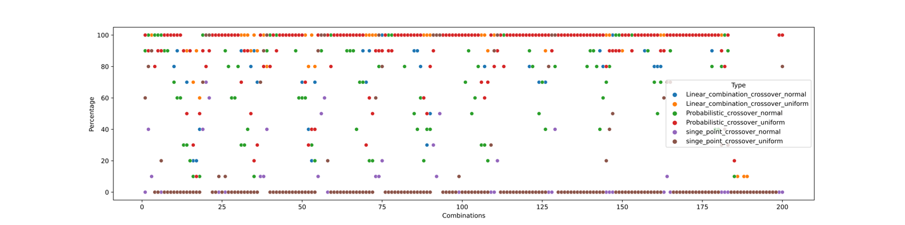

Figure 2-78 shows SSGA for F22 in Experiment4. The x axis is the index for parameter combination, the y axis is percentage value showing the number of times that global minima has been found among 10 runs. The x axis ranges from 1 to 200 which corresponds to the 1 to 200 parameter combination in this experiment. The y axis ranges from 0 to 100.

Figure 2‑78

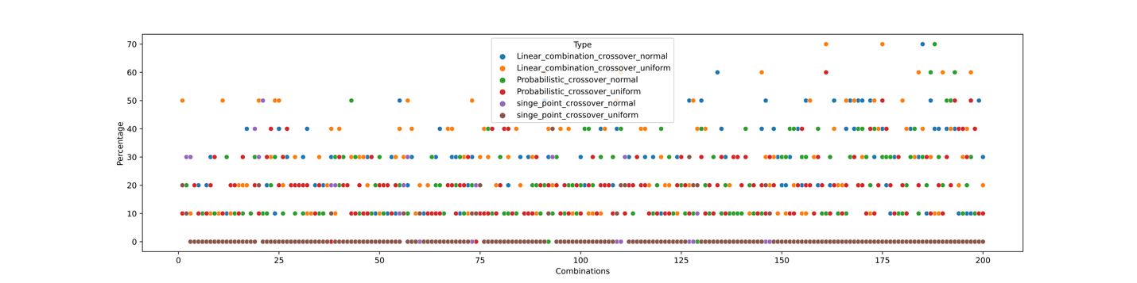

### Best 20 parameter combination

I calculate the sum of every solution for each parameter combination and then I have a list with 200 numbers for each function. I ranked them in an ascending order and choose the first 20 which is also the best 20. Since only 6 functions are tested in this experiment. The best 20 of each function is different. I merged the best 20 for each function and chosen the most frequent 20 among 120.

Table 2-9 shows the best 20 parameter combinations. The column indexes show the name of each parameter, the row indexes show the ID for each parameter combination.

Table 2‑9

|  |  |  |  |  |  |
| --- | --- | --- | --- | --- | --- |
| ID | iterations | mutation rate | num individuals | range mutation | crossover probability |
| 1 | 1000000 | 1 | 200 | 0.01 | 0.6 |
| 2 | 1000000 | 2 | 200 | 0.01 | 0.6 |
| 3 | 1000000 | 2 | 200 | 0.01 | 0.5 |
| 4 | 1000000 | 0.1 | 200 | 0.25 | 0.7 |
| 5 | 1000000 | 0.1 | 200 | 0.25 | 0.6 |
| 6 | 1000000 | 0.18 | 200 | 0.25 | 0.7 |
| 7 | 1000000 | 0.2 | 200 | 0.25 | 0.7 |
| 8 | 1000000 | 1 | 100 | 0.01 | 0.7 |
| 9 | 1000000 | 1 | 200 | 0.01 | 0.7 |
| 10 | 1000000 | 1 | 200 | 0.01 | 0.5 |
| 11 | 1000000 | 1 | 100 | 0.01 | 0.6 |
| 12 | 1000000 | 2 | 100 | 0.01 | 0.7 |
| 13 | 1000000 | 1 | 100 | 0.01 | 0.5 |
| 14 | 1000000 | 2 | 100 | 0.01 | 0.5 |
| 15 | 1000000 | 2 | 100 | 0.01 | 0.6 |
| 16 | 1000000 | 0.1 | 100 | 0.25 | 0.7 |
| 17 | 1000000 | 0.18 | 100 | 0.25 | 0.7 |
| 18 | 1000000 | 0.1 | 200 | 0.25 | 0.5 |
| 19 | 1000000 | 0.5 | 100 | 0.01 | 0.7 |
| 20 | 1000000 | 0.5 | 200 | 0.01 | 0.7 |

## Experiment5: SSGA in 50 dimensions

Table 2-10 shows the environment for Experiment5.

Table 2‑10

| Experiment5 | Setting |
| --- | --- |
| Algorithm | SSGA |
| Functions tested | All the functions |
| Number of parameters | 5 |
| Crossover type | Single point crossover probabilistic crossover linear combination crossover |
| Mutation type | Uniform Normal |
| Multiple runs  Dimensions | 10  50 |

Experiment5 uses the best 20 parameter combinations obtained in experiment4. See Table 2-9.

### Percentage Table

For convenience, Table 2-11 is used instead of naming.

Table 2‑11

| Experiment5 | Setting |
| --- | --- |
| Mutation type | 0: Uniform 1: Normal |
| Crossover type | 0: probabilistic crossover 1: Single point crossover 2: linear combination crossover |

For example, percentage table 01 means SSGA using mutation type 0 and crossover type 1.

Table 2-12 shows the percentage table 01 generated by SSGA.

Percentage table 01 means SSGA using mutation type 0 and crossover type 1. The column indexes are corresponding to the ID of the best 20 parameter combination. The row indexes are corresponding to the test functions. Red represents smaller values and green represents larger values.

Table 2‑12



Figure 2-79 shows the bar plot for percentage table 01.

The x axis represents best parameter combination ID from 1 to 20, the y axis represents the corresponding percentage value for each parameter combination. Different colors represent different test functions.

Figure 2‑79

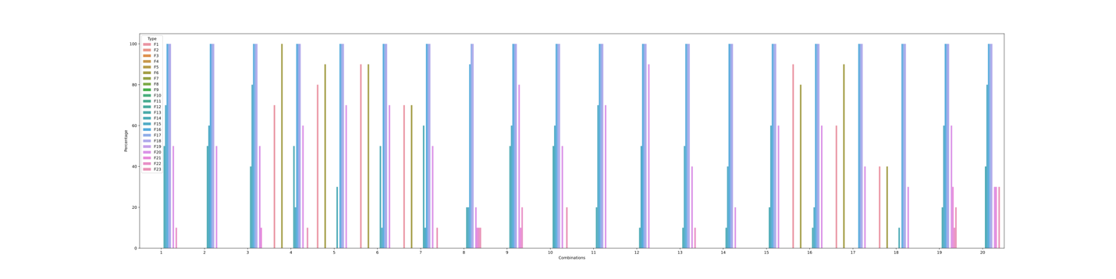

Table 2-13 shows the percentage table 00 generated by SSGA.

Percentage table 00 means SSGA using mutation type 0 and crossover type 0. The column indexes are corresponding to the ID of the best 20 parameter combination. The row indexes are corresponding to the test functions. Red represents smaller values and green represents larger values.

Table 2‑13



Figure 2-80 shows the bar plot for percentage table 00.

The x axis represents best parameter combination ID from 1 to 20, the y axis represents the corresponding percentage value for each parameter combination. Different colors represent different test functions.

Figure 2‑80

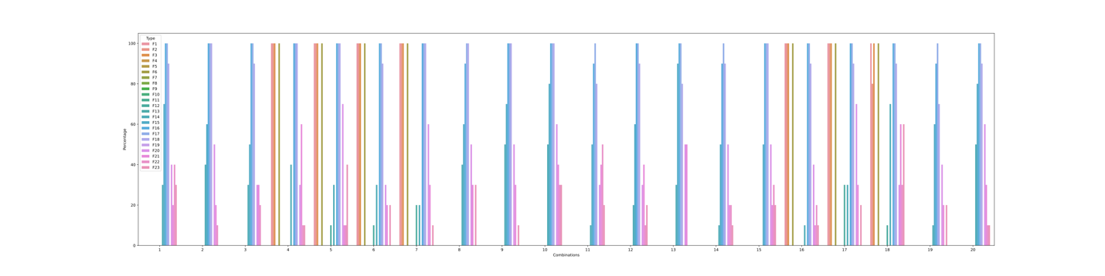

Table 2-14 shows the percentage table 11 generated by SSGA.

Percentage table 11 means SSGA using mutation type 1 and crossover type 1. The column indexes are corresponding to the ID of the best 20 parameter combination. The row indexes are corresponding to the test functions. Red represents smaller values and green represents larger values.

Table 2‑14



Figure 2-81 shows the bar plot for percentage table 11. The x axis represents best parameter combination ID from 1 to 20, the y axis represents the corresponding percentage value for each parameter combination. Different colors represent different test functions.

Figure 2‑81

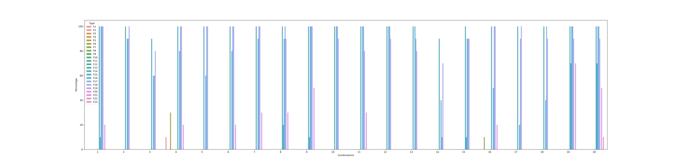

Table 2-15 shows the percentage table 10 generated by SSGA. Percentage table 10 means SSGA using mutation type 1 and crossover type 0. The column indexes are corresponding to the ID of the best 20 parameter combination. The row indexes are corresponding to the test functions. Red represents smaller values and green represents larger values.

Table 2‑15



Figure 2-82 shows the bar plot for percentage table 10.

The x axis represents best parameter combination ID from 1 to 20, the y axis represents the corresponding percentage value for each parameter combination. Different colors represent different test functions.

Figure 2‑82

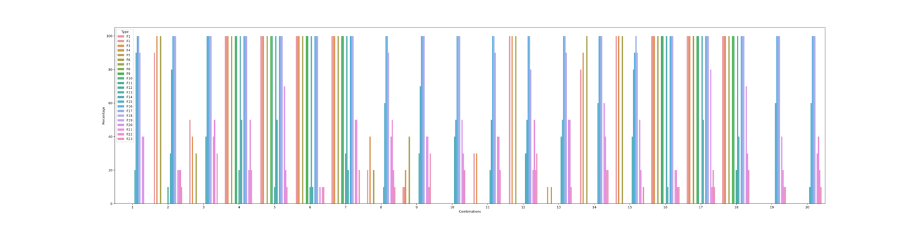

Table 2-16 shows the percentage table 02 generated by SSGA.

Percentage table 02 means SSGA using mutation type 0 and crossover type 2. The column indexes are corresponding to the ID of the best 20 parameter combination. The row indexes are corresponding to the test functions. Red represents smaller values and green represents larger values.

Table 2‑16



Figure 2-83 shows the bar plot for percentage table 02.

The x axis represents best parameter combination ID from 1 to 20, the y axis represents the corresponding percentage value for each parameter combination. Different colors represent different test functions.

Figure 2‑83

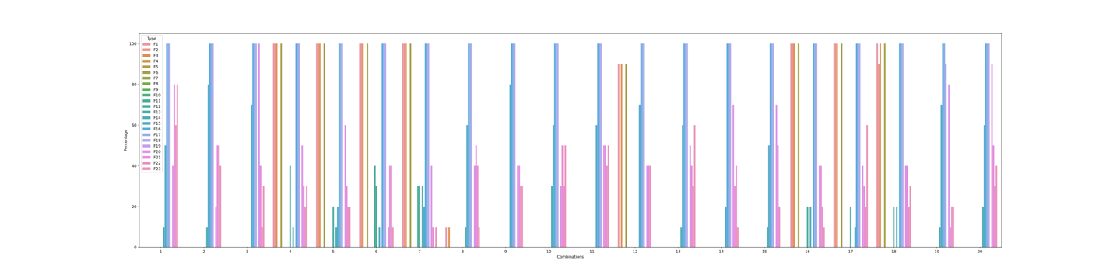

Table 2-17 shows the percentage table 12 generated by SSGA. Percentage table 12 means SSGA using mutation type 1 and crossover type 2. The column indexes are corresponding to the ID of the best 20 parameter combination. The row indexes are corresponding to the test functions. Red represents smaller values and green represents larger values.

Table 2‑17



Figure 2-84 shows the bar plot for percentage table 12. The x axis represents best parameter combination ID from 1 to 20, the y axis represents the corresponding percentage value for each parameter combination. Different colors represent different test functions.

Figure 2‑84

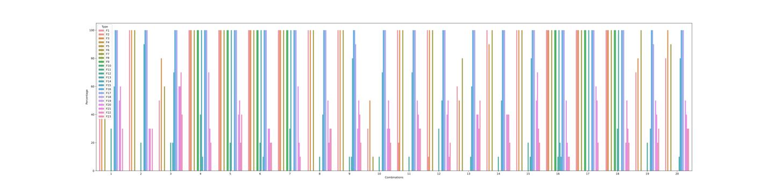

### Conclusion of Experiment5

1. SSGA performs very well on certain functions, e.g., F1, F3, F6, F16, F17, F18. The best 20 parameter combinations are chosen from the results of Experiment 4 on F1, F3, F6, F12, F18 and F22. I think this may be the reason why they perform particularly well compared to other functions.
2. F9, F10, F15, F21, F22, F23 and F12 perform well on certain parameter combinations while perform bad on certain parameter combinations.
3. The other functions perform poorly.

### Issues with Experiment5

#### F19

F19 and F20 are almost identical, F20 is even more complicated than F19. F20 can find the optimal value (optimal value is -3.32) while F19 cannot find the minima. I checked the other parameters and there is no problem with the input, and since F20 can find the minimum, f19 should work as well. I checked the raw data of F19's solutions, it looks like that F19 has been converged with all the solutions equal to -0.30048. But the minimum value written on reference2 of appendix A is -3.86.

#### Bad performance on power computation

I think the SSGA algorithm performs poorly when it comes to power computation, especially when the domain is very wide. The functions 16 and 18 that perform particularly well also have power computation, but the domains of these two functions are very narrow.

As mentioned before, new genes are only generated when doing mutation. The given mutation rate and the range for mutation is low and narrow, so it is hard for some high dimensional functions with a wide domain to evolve at a satisfying speed when encounter power computation for new gene is hard to appear in the population.

## Experiment6: Baldwin and Lamarck on best 20

Table 2‑18

| Experiment6 | Setting |
| --- | --- |
| Mutation type | 0: Uniform 1: Normal |
| Crossover type | 0: probabilistic crossover 1: Single point crossover 2: linear combination crossover |
| Local search type | 0: Uniform 1: Normal |

Table 2-18 shows the naming rules for Lamarck and Baldwin algorithms. Table 2-19 shows the environment for Experiment6.

Table 2‑19

| Experiment6 | Setting |
| --- | --- |
| Algorithm | Baldwin, Lamarck |
| Functions tested | All the functions |
| Parameter combination | Best 20 in Experiment4 |
| Crossover type | Single point crossover probabilistic crossover linear combination crossover |
| Mutation type | Uniform Normal |
| Local search type | Uniform Normal |
| Multiple runs  Dimensions | 10  50 |

### Percentage tables

Figure 2-85 shows percentage results for Baldwin101.

The x axis represents best parameter combination ID from 1 to 20, the y axis represents the corresponding percentage value for each parameter combination. Different colors represent different test functions. Baldwin 101 means using mutation type 1, crossover type 0 and local search 1. See table 2-18.

Figure 2‑85

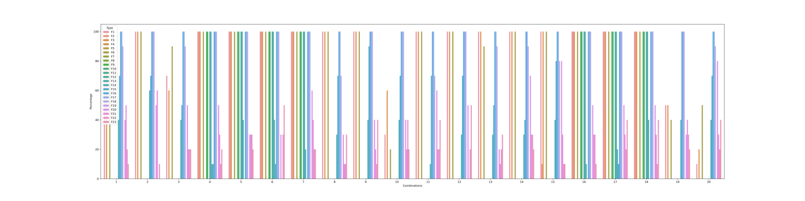

Table 2-20 shows the percentage table of Baldwin101 generated by Baldwin. Baldwin101 means using mutation type 1, crossover type 0 and local search 1. The column indexes are corresponding to the ID of the best 20 parameter combination. The row indexes are corresponding to the test functions. Red represents smaller values and green represents larger values.

Table 2‑20



Figure 2-86 shows percentage results for Baldwin111.The x axis represents best parameter combination ID from 1 to 20, the y axis represents the corresponding percentage value for each parameter combination. Different colors represent different test functions. Baldwin 111 means using mutation type 1, crossover type 1 and local search 1. See table 2-18.

Figure 2‑86

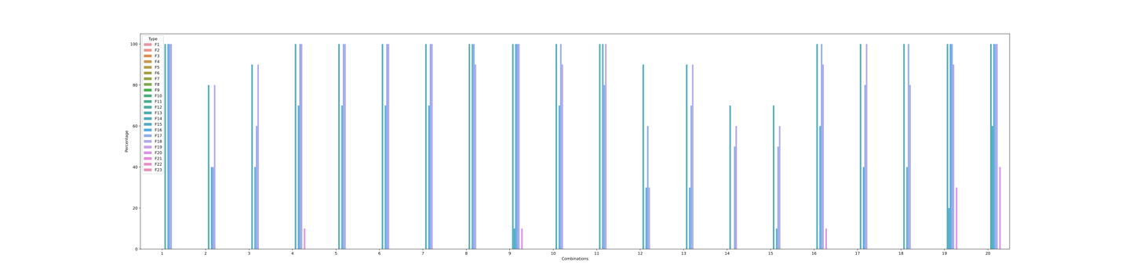

Table 2-21 shows the percentage table of Baldwin111 generated by Baldwin.

Baldwin111 means using mutation type 1, crossover type 1 and local search 1. The column indexes are corresponding to the ID of the best 20 parameter combination. The row indexes are corresponding to the test functions. Red represents smaller values and green represents larger values.

Table 2‑21



Figure 2-87 shows percentage results for Baldwin121.

The x axis represents best parameter combination ID from 1 to 20, the y axis represents the corresponding percentage value for each parameter combination. Different colors represent different test functions. Baldwin 121 means using mutation type 1, crossover type 2 and local search 1. See table 2-18.

Figure 2‑87

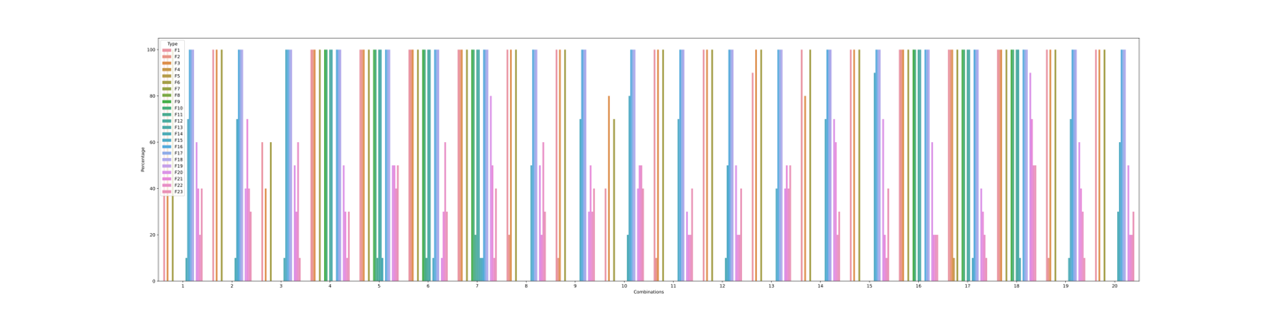

Table 2-22 shows the percentage table of Baldwin121 generated by Baldwin.

Baldwin121 means using mutation type 1, crossover type 2 and local search 1. The column indexes are corresponding to the ID of the best 20 parameter combination. The row indexes are corresponding to the test functions. Red represents smaller values and green represents larger values.

*Table 2‑22*



Figure 2-88 shows percentage results for Lamarck101. The x axis represents best parameter combination ID from 1 to 20, the y axis represents the corresponding percentage value for each parameter combination. Different colors represent different test functions. Lamarck 101 means using mutation type 1, crossover type 0 and local search 1. See table 2-18.

*Figure 2‑88*

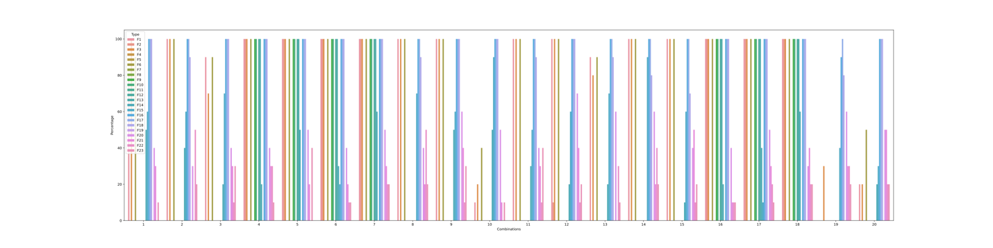

Table 2-23 shows the percentage table of Lamarck101 generated by Lamarck.Lamarck101 means using mutation type 1, crossover type 0 and local search 1. The column indexes are corresponding to the ID of the best 20 parameter combination. The row indexes are corresponding to the test functions. Red represents smaller values and green represents larger values.

Table 2‑23



Figure 2-89 shows percentage results for Lamarck111.

The x axis represents best parameter combination ID from 1 to 20, the y axis represents the corresponding percentage value for each parameter combination. Different colors represent different test functions. Lamarck 111 means using mutation type 1, crossover type 1 and local search 1. See table 2-18.

Figure 2‑89

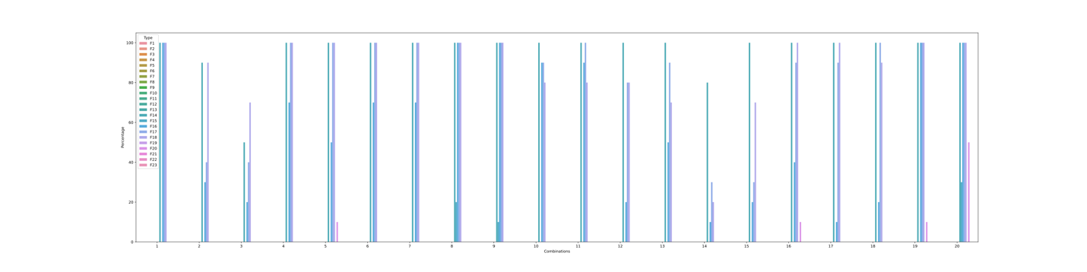

Table 2-24 shows the percentage table of Lamarck111 generated by Lamarck.

Lamarck111 means using mutation type 1, crossover type 1 and local search 1. The column indexes are corresponding to the ID of the best 20 parameter combination. The row indexes are corresponding to the test functions. Red represents smaller values and green represents larger values.

Table 2‑24



Figure 2-90 shows percentage results for Lamarck121.

The x axis represents best parameter combination ID from 1 to 20, the y axis represents the corresponding percentage value for each parameter combination. Different colors represent different test functions. Lamarck 121 means using mutation type 1, crossover type 2 and local search 1. See table 2-18.

Figure 2‑90

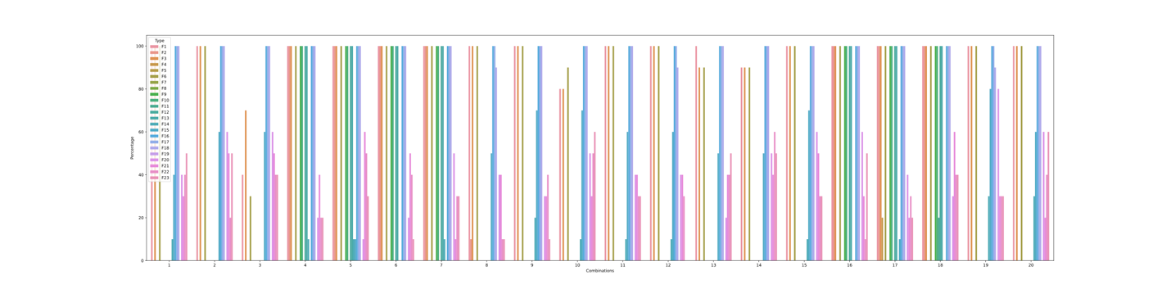

Table 2-25 shows the percentage table of Lamarck121 generated by Lamarck.

Lamarck121 means using mutation type 1, crossover type 2 and local search 1. The column indexes are corresponding to the ID of the best 20 parameter combination. The row indexes are corresponding to the test functions. Red represents smaller values and green represents larger values.

Table 2‑25



### Evaluation of local search procedures

We have 2 mutation types and 3 crossover types for SSGA. For Baldwin or Lamarck algorithm, we have two additional local search types. This section is set to compare the performance of percentage table between SSGA and Lamarck or Baldwin algorithm.

The number of Percentage tables for SSGA should be 2*3 = 6.

The number of Percentage tables for Baldwin should be 2*2*3 = 12. (We only have 3 so far.)

The number of Percentage tables for SSGA should be 2*2*3 = 12. (We only have 3 so far.)

#### Comparison between SSGA and Lamarck

Table 2-26 shows the results = Lamarck101 – SSGA10. The column indexes are corresponding to the ID of the best 20 parameter combination. The row indexes are corresponding to the test functions. Lamarck101 means using mutation type 1, crossover type 0 and local search 1. SSGA10 means using mutation type 1, crossover type 0. Red represents smaller values and green represents larger values.

Table ‑



Table 2-27 shows the results = Lamarck111 – SSGA11. The column indexes are corresponding to the ID of the best 20 parameter combination. The row indexes are corresponding to the test functions. Lamarck111 means using mutation type 1, crossover type 1 and local search 1. SSGA11 means using mutation type 1, crossover type 1. Red represents smaller values and green represents larger values.

Table ‑



Table 2-28 shows the results = Lamarck121 – SSGA12. The column indexes are corresponding to the ID of the best 20 parameter combination. The row indexes are corresponding to the test functions. Lamarck121 means using mutation type 1, crossover type 2 and local search 1. SSGA12 means using mutation type 1, crossover type 2. Red represents smaller values and green represents larger values.

Table ‑



#### Comparison between SSGA and Baldwin

Table 2-29 shows the results = Baldwin101 – SSGA10. The column indexes are corresponding to the ID of the best 20 parameter combination. The row indexes are corresponding to the test functions. Baldwin101 means using mutation type 1, crossover type 0 and local search 1. SSGA10 means using mutation type 1, crossover type 0. Red represents smaller values and green represents larger values.

Table ‑



Table 2-30 shows the results = Baldwin111 – SSGA11. The column indexes are corresponding to the ID of the best 20 parameter combination. The row indexes are corresponding to the test functions. Baldwin111 means using mutation type 1, crossover type 1 and local search 1. SSGA11 means using mutation type 1, crossover type 1. Table ‑ is shown as the following picture. Red represents smaller values and green represents larger values.



Table 2-31 shows the results = Baldwin121 – SSGA12. The column indexes are corresponding to the ID of the best 20 parameter combination. The row indexes are corresponding to the test functions. Baldwin121 means using mutation type 1, crossover type 2 and local search 1. SSGA11 means using mutation type 1, crossover type 2. Red represents smaller values and green represents larger values.

Table ‑



### Conclusion of Experiment6

1. The local search procedures in current Baldwin and Lamarck algorithm does not improve the performance of SSGA much.
2. The performance of Lamarck algorithm is slightly better than that of Baldwin algorithm.  
   In Baldwin, the genotype and phenotype of an individual are different, Baldwin selected the best individual based on the phenotype, and then produced offspring based on the genotype of this best individual. The point is the genotype of the best individual selected according to the phenotype may not be the best genotype among all individuals. In this case, the individual used to produce the offspring in each iteration of Baldwin may not be the best in the whole group.  
   In Lamarck, although the genotype and phenotype are different, Lamarck selects the best individual according to the phenotype, and then produces offspring according to the phenotype of this best individual, new individuals are generated based on the best one in the whole group in each iteration.  
   Therefore, the performance of Lamarck algorithm is slightly better than that of Baldwin algorithm.
3. The overall performance:  
   Baldwin 101> Baldwin 121> Baldwin 111  
   Lamarck 101> Lamarck 121> Lamarck 111

# Conclusion and Further Work

In this summer project, we implemented Baldwin and Lamarck algorithms to find the global minima of the test functions. During the process of exploring good parameter combinations. We implemented SSGA, the difference between SSGA and Baldwin, Lamarck is the local search part. SSGA performs well on certain functions, but the current local search procedures still need to be improved.

Generally speaking,

1. Regarding the performance for crossover type: probabilistic crossover is slightly better than linear combination crossover, both are much better than single point crossover.
2. Regarding the performance for mutation type: normal is better than uniform.

Future work should focus on the local search parts and try to make some improvements for Lamarck and Baldwin.

# References

[1] N. Awad, M. Ali, J. Liang, B. Qu, P. Suganthan, and P. Definitions, “Evaluation criteria for the cec 2017 special session and competition on single objective real-parameter numerical optimization,” Tech. Rep., 2016.

[2]Bereta, M. Baldwin effect and Lamarckian evolution in a memetic algorithm for Euclidean Steiner tree problem. *Memetic Comp.* **11**, 35–52 (2019). <https://doi.org/10.1007/s12293-018-0256-7>

[3]Mallawaarachchi, V. (2020, March 1). *Introduction to genetic algorithms - including example code*. Medium. Retrieved August 30, 2022, from <https://towardsdatascience.com/introduction-to-genetic-algorithms-including-example-code-e396e98d8bf3>

[4]Wikimedia Foundation. (2022, February 3). *Selection (genetic algorithm)*. Wikipedia. Retrieved August 30, 2022, from <https://en.wikipedia.org/wiki/Selection_(genetic_algorithm)>

[5]Wikimedia Foundation. (2022, May 3). *Crossover (genetic algorithm)*. Wikipedia. Retrieved August 30, 2022, from <https://en.wikipedia.org/wiki/Crossover_(genetic_algorithm)>

[6]Medium. 2022. *Introduction to Optimization with Genetic Algorithm*. [online] Available at: <https://towardsdatascience.com/introduction-to-optimization-with-genetic-algorithm-2f5001d9964b> [Accessed 30 August 2022].